Tennis Analysis Tool

Yuyao Xie

Table of Contents

Analysis 5

Problem Identification 5

Why is it suited to a computational solution 5

Stakeholders 6

Interview Questions 6

Responses 7

Why is it appropriate to stakeholder’s needs 8

Research 8

SwingVision (https://swing.tennis/) 9

Tennis Analytics (https://www.tennisanalytics.net/) 10

PlaySight (https://playsight.com/) 12

Parts that I can apply to my Solution 13

Essential Features of the Proposed Solution 13

Limitations 14

Requirements 14

Hardware 14

Software 15

Success Criteria 15

Design 16

Problem Decomposition 16

User Interface 19

Court Key Points Model Training 21

Data preparation 22

Model Definition 23

Training 23

Court Key Points Detection 24

__init__ 24

Predict 25

Draw Keypoints 26

Draw Keypoints On Video 26

Player Detection Model 26

Filter Players 27

Choose Players 28

Detect Frames 29

Detect Frame 29

Ball Detection Model 30

Get Ball Shot Frames 30

Detect Frames 31

Detect Frame 32

Draw Bounding Boxes 32

Deriving the Speed of an Object 33

Mini Court 36

Convert Meters to Pixels 36

Get Coordinates 36

Set Key Points 37

Draw Mini Court 37

Convert Object Coordinates 38

Draw Points 38

Key Variables 38

Testing 40

Iterative Development Phase 40

Post Development Phase 41

Development 43

Stage 1: Court Keypoints Detection 43

Model Training 43

Key Point Detection 46

Review 48

Criteria Fulfilled 49

Validation 49

Stage 2: Player Detection 50

Review 53

Criteria Fulfilled 53

Validation 53

Stage 3: Ball Detection Model 54

Remedial Action - Interpolation Research 55

Ball Tracker Class 56

Review 60

Criteria Fulfilled 60

Validation 61

Stage 5: Performance Metrics Extraction 61

Criteria Fulfilled 63

Review 64

Validation 64

Stage 6: Mini Court Diagram 65

Criteria Fulfilled 71

Review 71

Validation 72

Stage 7: Video Player 73

Remedial Action – Kivy 75

Criteria Fulfilled 78

Review 79

Validation 79

Post-Development Testing 79

Testing for Function and Robustness 79

Testing for Usability 84

Hardware 85

Stakeholder Feedback 86

Interview 86

Reflection 86

Evaluation 87

Success Criteria 87

Simple and intuitive interface design 87

Make the application and processing of video fast 88

Outputs video with labelled objects & Train model to identify the key points of the tennis court & Train object detection models that can identify the position of the tennis balls & Train object detection models that can identify the position of the players 89

Derive the speed of players and balls & Display of performance data 91

Generate heat map diagram of shots 92

File Selection Interface 93

Video player to play back output labelled video 94

Video controls for the video player 95

Issues with Usability Features 95

Limitations 96

Maintenance 98

Full Code 101

Main.py 101

GUI.py 105

Editor.kv 108

Ball_training.ipynb 110

Court_points_training.ipynb 110

Ball_tracker.py 113

Player_tracker.py 116

Court_line_detector.py 118

Bbox_utilities.py 120

Conversion_utilities.py 121

Stats_drawer_utilities.py 121

Video_utilities.py 123

Mini_court.py 123

# Analysis

## Problem Identification

Described and justified the features that make the problem solvable by computational methods, explaining why it is amenable to a computational approach.

Tennis is a highly competitive racket sport that is played on a multitude of levels. The game starts with a legal serve, resulting in a rally where players attempt to score a point. Points can be scored either if it lands on the opponent’s side and cannot be returned or if the opponent returns the ball outside of the margins of the court. However, its modern form is a strategic battle of setting up angles and identifying weaknesses in the opposition’s style.

To improve their performance, many players, recreational and performance, record themselves to review their technique but to also see the bigger tactical picture. Due to the complexity and freedom of gameplay, one can get easily overwhelmed when interpreting their own games. In particular they face two big challenges:

1. Players are unable to gauge numerically the speed of their shots themselves.
2. Tennis involves numerous rallies per match, with multiple shots being played in quick succession. Players struggle to track their shot selection patterns across long sessions, which makes it difficult to identify areas for improvement.

At the moment, tennis analysis tools are prohibitively expensive or outdated; making them inaccessible for amateur players. This gap presents an opportunity to develop an accessible tool that empowers players to improve their games by offering insights in their performance.

## Why is it suited to a computational solution

Initially, my goal was to develop an analysis tool for badminton, as I am a badminton player myself and was motivated by a desire to improve my own game. However, I encountered significant challenges due to the limited availability of court-based datasets for badminton.

**Justification:** Tennis, by contrast, has a wealth of accessible data and structured information, making it a more suitable choice for a data-driven analysis tool.

While professional tennis tournaments often employ multiple high-speed cameras to track the ball and analyse player movements, such solutions are costly and impractical for everyday players.

**Justification:** Therefore, the goal is to develop a computational tool that requires minimal hardware (just a smartphone camera).

Due to the variability of tennis matches, traditional statistical models are ineffective for analysis. Whereas, Convolutional Neural Networks (CNNs) can classify video footage whilst being accurate and efficient. They can find key events such as player and ball movement.

**Justification:** This is far less time consuming in comparison to manual human input. What’s more, the system would be able to detect the ball's location in each frame and track its movement across the court to determine shot speed which would be challenging to calculate by hand.

Furthermore, a computational solution would be able to gather an extensive breakdown of performance metrics, such as shot speed, placement, and shot success rates. This data-driven approach is crucial for players who want to improve their game, as it highlights patterns and trends that are often difficult to observe in real time.

**Justification:** The ability to interpret such data is vital for players to identify specific areas for improvement and track progress over time, giving them a clear, quantitative basis for their training strategies.

## Stakeholders

Identified suitable stakeholders for the project and described them explaining how they will make use of the proposed solution and why it is appropriate to their needs.

### Interview Questions

1. **Can you describe how you currently analyse your tennis matches (if at all)? What methods or tools do you use?**
2. **What are the biggest challenges you face when trying to improve your game?**
3. **What are the most important factors you want to know after a match? (e.g., shot speed, shot placement, accuracy, shot type, rally length)**
4. **What do you currently struggle with the most when analysing your game? (e.g., shot speed estimation, rally breakdown, shot selection patterns)**
5. **Do you currently record your tennis matches? If so, how do you use the footage afterward?**
6. **Would you find it useful to get an automated tactical analysis or recommendations (e.g., which shots you use most, tendencies in your play, opponent weaknesses)?**

### Responses

#### Vincent

1. I ask other people. I get coaches to watch and just random people to watch. Sometimes I film myself.
2. Figuring out what to improve.
3. Serve percentage and shot selection at certain times
4. I can’t definitely analyse my shot speed. Shot choice is quite hard in game.
5. Sometimes I film but not often. If I film I use it to brag.
6. Yas!

#### Harry

1. I used to use SwingVision for match tracking.
2. Discipline of sticking to new technique or strategy when it's not initially working
3. I’m interested in learning about patterns of play and serve speed, mostly for fun.
4. I struggle the most with analysing the effectiveness of different play patterns.
5. No, I don’t record my matches.
6. Yes, I would find automated tactical analysis useful.

#### Sophia

1. I observe my opponent’s strengths and weaknesses and create a tactical plan, which I test in the first game or so to see if it’s effective. I adjust based on how well it works.
2. My biggest challenges are staying consistent when a match isn’t in my favour or when I’m playing a stronger opponent. Mentally staying strong and not giving up is often harder than technical issues.
3. The most important factors to me are first-serve accuracy and speed, return accuracy, baseline rally length, and the number of aces.
4. I find it challenging to analyse shot selection in different scenarios, particularly whether my decisions were intentional or random due to pressure.
5. I don’t record my matches unless someone else helps. When I do, I mainly review basic movements and reaction times.
6. I’d find automated tactical analysis very useful, especially if it’s data-driven.

### Why is it appropriate to stakeholder’s needs

As a globally popular sport, tennis is played by over 87 million people from recreational players to professionals. Therefore, there are undoubtedly a large number of potential stakeholders.

The primary stakeholders can be separated into two categories:

1. **Tennis Players (All Levels)**

Beginners and intermediate players often do not fundamentally understand how to identify areas of improvement in the first place. As such, they could greatly benefit from preset insights into their performance.

Advanced players and professionals, on the other hand, are often looking for marginal gains in performance and need a detailed breakdown. Through real discrete data, this tool would allow players at all levels to set measurable goals and track progress. What’s more, by providing labelled videos, their game would be more easily understood. Players can use the information from the tool for fun, self-interest of to develop their gameplay.

1. **Coaches**

Tennis coaches play a crucial role in player development, from introducing basic skills to fine-tuning professional skills. However, manual match analysis can be time-consuming, and subtle patterns in a player’s performance are often difficult to detect through physical observation alone. A digital tool could streamline this process by automatically generating key performance metrics. Coaches could use this data to provide more targeted feedback based on areas of improvement. Additionally, by using a consistent analytical framework, coaches would be able to compare different players and track a player’s progress over time, which could improve the quality of feedback and make training more effective.

## Research



Researched the problem in-depth looking at existing solutions to similar problems, identifying and justifying suitable approaches based on this research.

### SwingVision (<https://swing.tennis/>)

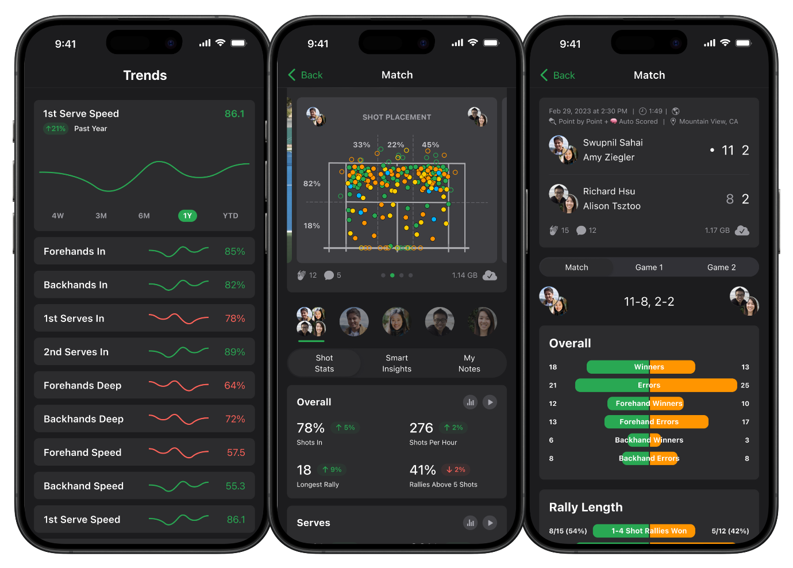

#### Pricing

SwingVision offers a free tier with basic features, and a Premium subscription available for $14.99 per month or $119.99 annually. The Premium plan includes advanced features such as detailed shot analysis and session summaries.

#### Accessibility

Currently, SwingVision is accessible only on iOS devices (i.e. iPhone, iPad, or Apple Watch). This exclusivity limits accessibility for Android users, which account for 56% of all phone sales in 2023 (<https://backlinko.com/iphone-vs-android-statistics>).

#### Machine Learning Usage

SwingVision applies machine learning extensively through its real-time computer vision models, which enable automatic shot tracking and stroke tagging. The tracking identifies ball speeds and placement on the court, making insights available almost instantaneously during a practice session or match.

#### Player Improvement Features

The app is designed to give players actionable feedback in response to training or play. Real-time shot tracking and analysis provide responsive data, allowing players to make adjustments on the fly. Additionally, the app offers a ‘Drill Mode’ where users can practise specific strokes or movements. Shot placement heatmaps visualise where each shot lands on the court, helping players detect patterns in their play. After each session, users can review summaries that detail shot breakdowns and common mistakes, allowing them to set goals based on specific improvement areas.

#### User Interface

SwingVision has a sleek interface that presents data in a user-friendly format. Real-time metrics are displayed in easy-to-read overlays during video playback, while post-session stats are clearly organised, allowing players and coaches to review performance efficiently. The interface is accessible to players of all skill levels, making it suitable for both beginners and advanced users who seek quick access to comprehensive data.

#### Ideal For

SwingVision is particularly suitable for recreational players who are looking for an affordable and portable tool to track personal improvement over time.

### A screenshot of a tennis match Description automatically generatedTennis Analytics (<https://www.tennisanalytics.net/)>

#### Pricing

Tennis Analytics begins at approximately $100 per match for individual analysis, with custom pricing available for team packages.

#### Accessibility

The service is accessible via a web platform where users upload pre-recorded footage, making it versatile but reliant on video quality. It doesn’t offer real-time analysis, as data is reviewed and processed post-match, requiring a delay before insights are available.

#### Machine Learning Usage

The use of machine learning in Tennis Analytics is moderate and is mainly employed to automate video tagging and pattern recognition. However, significant manual input from analysts complements the technology. This blend of ML and human expertise allows for precise data interpretation tailored to competitive match preparation.

#### Player Improvement Features

Tennis Analytics provides a wide array of features for player improvement. Users receive customised reports detailing player weaknesses and areas for improvement. The platform also supports opponent analysis, providing insights into opponents’ patterns and tendencies based on past matches, which can be crucial for match preparation. For technical adjustments, Tennis Analytics tags every point, allowing coaches to filter specific types of shots or errors to study in detail.

#### User Interface

The interface of Tennis Analytics is data-focused, with sophisticated tools for filtering and organising match events. Although not as visually intuitive as other apps designed for individual users. The design may be complex for beginners but is highly effective for advanced users and team coaches who require professional-grade insights.

#### Ideal For

Tennis Analytics is ideal for college teams and professional coaches seeking customised in-depth insights. Its high level of detail makes it a preferred choice for players who require comprehensive match analysis over real-time feedback.

### PlaySight (<https://playsight.com/>)

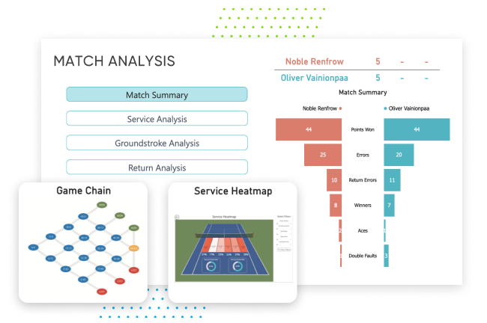

#### Pricing

PlaySight’s Smart Court setup starts at $10,000, with monthly subscriptions beginning at $90. The high installation cost makes it feasible mainly for clubs, academies, and institutions.

Accessibility

The service requires dedicated PlaySight Smart Court installations, typically found in well-funded clubs or universities, as it relies on specialised camera setups for 3D shot tracking.

#### Machine Learning Usage

PlaySight incorporates high levels of machine learning for 3D player and shot tracking, multi-angle replay, and event tagging. Its ML models capture comprehensive player movement and shot data, allowing for analysis of performance from multiple camera angles.

#### Player Improvement Features

PlaySight is particularly valuable for its 3D replay capabilities, which provide players with multi-angle reviews and detailed shot trajectories and speeds. The platform also generates movement heatmaps, which visualise player positioning and court coverage, helping identify movement efficiency or positional weaknesses. Statistical summaries cover a range of metrics, from shots and errors to successful patterns, and players can share data with coaches remotely for feedback.

UserInterface

The PlaySight interface is highly visual and accessible navigation tools. The data presentation is user-friendly. While optimised for coaches and players in structured settings, the interface is approachable for a range of user skill levels, with options for granular analysis.

#### Ideal For

PlaySight is ideal for tennis clubs, and university programs that can support the required setup and subscription fees, offering players a facility-based analytics experience.

### Parts that I can apply to my Solution

The way that Swing Vision tags players and the ball with computer vision models will be incorporated into my solution.

**Justification:** Tagging with only machine learning removes the repetitive labour which is the main disadvantage of Tennis Analysis. It will make the application accessible for non-professional players.

Furthermore, it will also capture data similar to SwingVision and Playsight in terms of extracting ball and player speeds.

I will also incorporate a similar diagram to SwingVision’s shot map to provide an overview.

**Justification:** The feature saw highly positive customer reviews. The map removes a dimension from analysis of the game.

The sleek and modern appeal of SwingVision’s user interface will inspire my application’s design.

Another feature I want to incorporate is to allow for uploading of any video like in Tennis Analytics rather than be restricted to specialised cameras such as in PlaySight and operating system limitations in SwingVision.

## Essential Features of the Proposed Solution

Identified the essential features of the proposed computational solution explaining these choices.

My solution will provide a basic GUI for the user where you can press a button to upload your tennis gameplay recording. Following this, machine learning models will label the video and extract ball and player speeds. The application window will contain a video player with video sliders so that the user can select which part of the labelled video to pause on and fast forward or move back. The extracted data will be displayed in a formatted manner next to the video. It will show the speed of the ball and players at that exact moment in time. There will also be a shot diagram of a 2D court such that the user can watch the position where the ball had landed.

### Limitations

Identified and explained with justification any limitations of the proposed solution.

The main limitation of my solution is that the model will probably be in unreliable for general use.

**Justification:** The videos that can be processed by the machine learning models will be highly dependent on the dataset. This is likely to be professional games which have well-placed high-quality cameras. However, a phone camera will have record at a much lower quality and most players will not have access to the same angles that a professional camera can obtain.

A further limitation of the proposed solution is that the resultant data will still need to be interpreted by the end user.

**Justification:** The programme does not give direct human feedback. This is an issue that can be fixed with a large language model API, but it is not within the scope of the project.

## Requirements

Specified and justified the requirements for the solution including (as appropriate) any hardware and software requirements.

### Hardware

* **Camera** – The initial recording of tennis footage can be provided through any source (e.g. phone camera). This video file will then be uploaded to be processed through the user interface.
* **A computer with significant processing power** – Preferably, the computer will have a fast CPU and GPU to run the machine learning models faster. Moreover, at least 1GB of free storage for the code itself and any resultant video files.
* **Standard IO Peripherals** – A mouse or track pad is needed to press the buttons on the application.

### Software

* **IDE with Python** – All code is written in python, so a python interpreter is required
* **Pip** - To install the large number of required libraries
* **Tkinter** – This is the library that is used for the user interface
* **OpenCV, Ultralytics, Pickle, Pandas** – These are the major libraries that are used within the project backend

## Success Criteria

Identified and justified measurable success criteria for the proposed solution.

|  |  |  |
| --- | --- | --- |
| **Criteria** | **Justification** | **How to Evidence** |
| Simple and intuitive interface design | Maintains focus on the key backend features. | Screenshot of the main window |
| Make the application and processing of video fast | To reduce wait time for the user and enhance experience | Time the time taken to process the video |
| Outputs video with labelled objects | Increases the visualisation to help users to identify patterns | Screenshot of video that has labelled objects |
| Object detection model that can identify the position of the tennis balls | This allows for extraction of the ball speeds from any video frame | Utilise test data and visually check whether bounding box correctly outlines balls |
| Object detection model that can identify the position of the players | This allows for extraction of the player speeds from any video frame | Utilise test data and visually check whether bounding box correctly outlines players |
| Train model to identify the key points of the tennis court | Through the key points, I can subsequently align the coordinates of objects according to the angle of the camera | Comparison of model labelled key points and actual key points |
| Derive the speed of players and balls | The key output for the whole project that the end user wants from their selected video | Screenshot of numbers at each frame |
| Display of performance data | Clear representation of data such that the user can understand the output of the program | Screenshot of numerical data on user interface |
| Generate heat map diagram of shots | This is a more visual representation of shot patterns and condenses shot data | Screenshot of heat diagram on user  interface |
| File Selection Interface | To facilitate a direct method of selecting a file without needing to search for file path and hard code into application. This allows the user to input their own footage or games which they wish to be analysed rather than having prerequisite videos | Screenshot of opened file selection and selection of file |
| Video player to play back output labelled video | Allows the user to watch the labelled video inside the application without needing to search in files | Test whether able to watch entire videos |
| Video controls for the video player | Access to key moments in timeline and navigate frame by frame for analysis | Test all buttons and features of video controls |

# Design

## Problem Decomposition

Broken the problem down systematically into a series of smaller problems suitable for computational solutions, explaining and justifying the process.

Defined in detail the structure of the solution to be developed.

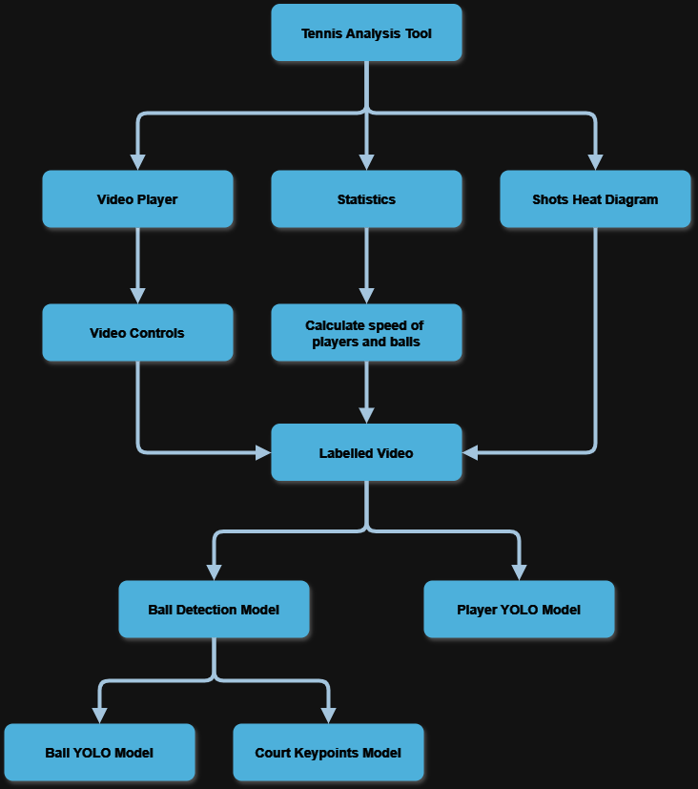

I have decomposed the project into its required outputs to be displayed on the user interface.

**Explanation:** This allows me to break down the problem into a structured approach to the solution.

**Justification:** The systematic approach will aid developing modular code, defining clear functions and file structuring. Furthermore, it makes maintenance easier in the future.

Rather than treating this as a monolithic problem, the displayed outputs have been categorised into 3 key groups: the labelled video, the statistics and the shots diagram.

**Explanation:** This splits the different problems into distinct computational tasks

**Justification:** The necessity for functional separation is because of allowing independent optimisation and verification of results before final integration

For the core processing pipeline, I have defined a stepwise transformation from the input data into the interpretable output data:

1. Detect the Players, the Ball and the Court Keypoints

* The computer vision models have to draw bounding boxes around the detected objects
* The coordinates of the objects can be extracted by using the geometry of the bounding box
* **Justification:** This is the most foundational step as without the positional information of the objects in the tennis game, it is impossible to perform further analysis and calculations

1. Adjust Coordinates

* Due to the camera angle of the footage, I need to adjust the coordinates to reflect the real-world
* The perspective adjustment can be done using the detected court keypoints and finding the transformation of perspective
* **Justification:** The ball and players’ position would be skewed if they are not adjusted correctly. Thus, the statistics would be incorrect and subsequent features such as the 2D court diagram would be ineffective.

1. Calculate Player and Ball Speed

* The velocity of the objects can be derived through frame-by-frame position changes over time
* Using the fps of the video file and the positions of the objects we can calculate an estimate for the average speeds
* The speed will be dynamically updated in a statistics panel
* **Justification:** In tennis, the speed of the ball is vital in indication of the players’ performance.

1. Generate Top-Down Court Diagram

* The normalised coordinates are mapped onto a scaled-down 2D representation
* This abstracts the player movements and shot placements
* **Justification:** The raw positional data lacks human readability which calls for a visual representation such as the court diagram. This can enhance coaches and players to obtain a high-level understanding of the match.

For each category, I will encapsulate them into separate classes. Thus, I can create objects and modify parameters.

**Justification:** I would be able to debug independently without affecting the whole system and scale by adding to respective modules.

## User Interface

Described, justifying choices made, the usability features to be included in the solution.

Input Video

Statistics

Video Player

Mini Court

Video Controls

For usability features I have ensured that the user interface will be a simple and intuitive design. This is made possible by only having one main window which contains all the components of the application.

**Justification:** Multi-window interfaces are often confusing for users and introduce a degree of complexity which is unnecessary for the software. One main window avoids distractions and reduces cognitive load.

Moreover, all of the buttons, components and text are large for better readability. Buttons will have light shades and text will have solid colours to stand out more.

**Justification:** Colour contrast principles ensure that critical information stands out to the user.

The in-built library Tkinter will be used to reduce complexity.

**Justification:** It is a lightweight library which circumvents external dependencies. Despite being less feature rich, it would simplify implementation.

To make the application and processing of video fast, I need to avoid re-training the model every time it is needed. I will store the pre-trained player and ball detection models as .pkl (Pickled Python Objects) and the PyTorch state dictionary of the court key points detection model.

**Justification:** Real-time processing would be impossible since training deep learning models is computationally time-consuming. Instead, loading pre-trained models will significantly reduce the load on the CPU and the speed of the programme as the input just needs to be fed into the models and long training time is not necessary.

#### Input Video

This button will allow the user to upload videos by providing a file dialog window to choose one of their video files. Following this selection, the selected video will be fed through the pipeline, and the processed video and statistics will be shown on the other components of the window.

**Justification:** The file dialog will be extremely similar to the file explorer application. Therefore, users will be more familiar, and less learning time is required. Automatic processing upon selections streamlines the workflow since no manual intervention is needed.

#### Video Player and Video Controls

This will be a video player to play back output labelled video and the video controls for the video player will allow the user to skip to any part of the video as well as pause. The user can watch back the labelled video for personal analysis. It is kept minimalist for ease of use.

**Justification:** A minimalist approach prevents convolution, keeping the focus on content rather than interface navigation. Skipping functionality means users can quickly access key moments, rather than watching the entire video.

#### Statistics Panel

This part of the user interface is panel that will be a display of performance metrics. It will show the numerical data of the video frame at that moment: the ball speed and the player speeds.

**Justification:** The user can align the actions in the video to the statistics easily as the statistics is alongside the video. A dedicated panel ensures clarity, preventing clutter in the main video display.

#### Mini Court Diagram

The mini court will be the generated heat map diagram of shots which give the player a better visual aid than numerical statistics. There will be a 2D layout of the tennis court and the players and the ball will be represented by bright circles for an abstracted view.

**Justification:** The use of bright circles ensures clear visibility, preventing confusion when tracking movements on the diagram.

## Court Key Points Model Training

Described the solution fully using appropriate and accurate algorithms justifying how these algorithms form a complete solution to the problem.

I will train a Resnet-50 model, a deep neural network architecture, on a manually filtered dataset of courts. The model will input individual frames of the input video and output the 14 x, y coordinates of the court’s key points.

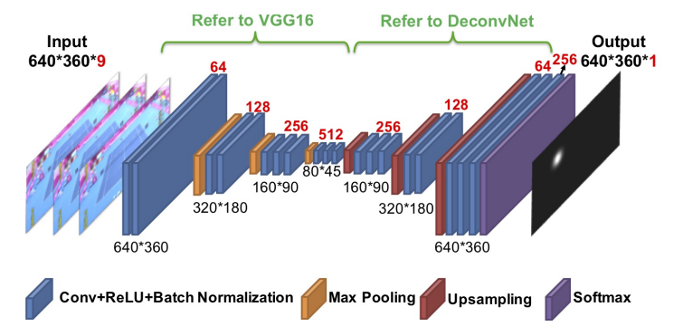

**Justification:** The model has been pre-trained on ImageNet which is a massive visual database with more than 14 million hand-annotated images. The 50-layer deep architecture will extract high-level features from the court which aligns with the function’s interests.

This dataset consists of 8841 images with 14 annotated points on the court’s preset key points. It will contain all types of broadcast courts such as hard, clay and grass so the model can cover the differences in appearance.

**Justification:** Including multiple court types prevents overfitting to a specific playing surface, ensuring versatility in different environments.

I will train this in a Jupyter notebook so I could utilise Google Colab’s free GPUs.

**Justification:** Machine learning models train at a higher performance when using GPUs in comparison to CPUs since GPUs are better at handling large amounts of data through parallel processing.

### Data preparation

Prior to training, it is essential for the dataset to be loaded, cleaned, and pre-processed. The pre-processing includes a number of steps:

1. Loading the images from the dataset directory
2. Converting images to RGB format
3. Resizing images to (224, 224)
4. Normalising pixel values
5. Scaling key point coordinates to match the resized image dimensions

**Justification:** Data preparation drastically improve machine learning inference. Resizing ensures uniform input size, which is required for batch training and compatibility with ResNet-50. Furthermore, it denoises the data as only key features remain. The higher quality of data through normalisation will promote model stability.

**Pseudocode:**

FUNCTION load_data(image_directory, data_file):

READ data from data_file

FOR each item in data:

READ image from image_directory

CONVERT image to RGB

RESIZE image to (224, 224)

NORMALIZE image

EXTRACT key points

SCALE key points to (224, 224)

RETURN processed images and key points

### Model Definition

Define the architecture of the neural network and initialise the model with pre-trained weights. Fine tune the model such that it outputs the x and y coordinates of the 14 key points, resulting in 28 outputs.

**Pseudocode:**

FUNCTION define_model():

LOAD pre-trained ResNet50 model

MODIFY last layer to output 28 values (14 key points * 2 coordinates)

RETURN model

model = define_model()

### Training

Here, I define the loss function (mean squared error) and deploy an Adam optimiser for faster convergence. Following this, I train the model over multiple epochs with batch processing.

**Justification:** Mean squared error loss penalises large error which is required in this scenario where we want precise locations of points. I have selected the Adam optimiser since it can adapt the learning rate dynamically. Finally, batch training reduces overfitting to small subsets of images.

**Pseudocode:**

FUNCTION train_model(model, training_data, epochs, learning_rate):

DEFINE mean squared error loss function

DEFINE optimiser with learning_rate

FOR epoch in range(epochs):

SET model to training mode

FOR each batch in training_data:

GET images and key points from batch

ZERO gradients

PREDICT key points using model

CALCULATE loss using loss function

BACKPROPAGATE loss

UPDATE model parameters

PRINT loss every 10 iterations

train_model(model, training_data, 20, 0.001)

torch**.**save(model**.**state_dict()**,** "court_points_model.pth")

*#* Save the model’s state dictionary

## Court Key Points Detection

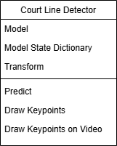The solution is structured into a class CourtLineDetector which takes in the path to the trained PyTorch state dictionary.

### __init__

Loading the pre-trained ResNet50 model, I modify the final layer to output 28 values to match the 14 key points’ x and y values. I will also define the transformation pipeline referenced earlier to preprocess input images.

**Pseudocode:**

FUNCTION __init__(self, model_path):

SET self.model to pre-trained ResNet50 model

MODIFY self.model.fc to torch.nn.Linear(self.model.fc.in_features, 28)

LOAD model weights from model_path with torch.load(model_path, map_location='cpu')

SET self.transform to transforms.Compose with:

transforms.ToPILImage()

transforms.Resize()

transforms.ToTensor()

transforms.Normalize()

### Predict

The image is converted from BGR to RGB, normalised, resized and reshaped using unsqueeze(0) to add a batch dimension, which is required for the model as it is expecting batch inputs. It retrieves the model predictions and converts them to a Numpy array. The keypoints are then scaled back to match the original image dimensions.

**Justification:** The

**Pseudocode:**

FUNCTION Predict(self, image)

CONVERT image from BGR to RGB using cv2.cvtColor(image, cv2.COLOR_BGR2RGB)

APPLY self.transform to image_rgb and add batch dimension with unsqueeze(0) SET image_tensor to transformed image

GET model predictions with self.model(image_tensor)

SET outputs to model predictions

CONVERT outputs to numpy array with outputs.squeeze().cpu().numpy()

SET keypoints to numpy array of predictions

GET original image dimensions with image.shape[:2]

SET original_h and original_w to image dimensions

SCALE keypoints[::2] by original_w / 224.0

SCALE keypoints[1::2] by original_h / 224.0

RETURN keypoints

### Draw Keypoints

This function draws keypoints on a given image. For each pair of keypoints, it calculates the x and y coordinates, draws the keypoint index near the keypoint using cv2.putText, and draws a circle at the keypoint location using cv2.circle. The modified image with keypoints is then returned.

**Pseudocode:**

FOR each pair of keypoints in keypoints:

SET x to int(keypoints[i]) + 10

SET y to int(keypoints[i+1])

DRAW text with keypoint index near the keypoint using cv2.putText

DRAW a circle at the keypoint location using cv2.circle

RETURN image

### Draw Keypoints On Video

For each frame in the input video frames, it draws keypoints on the frame using the draw_keypoints function and appends the modified frame to the output list. The list of frames with keypoints is then returned.

**Pseudocode:**

INITIALIZE output_video_frames as an empty list

FOR each frame in video_frames:

DRAW keypoints on frame using self.draw_keypoints

APPEND frame to output_video_frames

RETURN output_video_frames

## Player Detection Model

Given an input video file, the objects can be derived by utilising computer vision and drawing bounding boxes around each object. I will use a pre-trained You Only Look Once (YOLO model) that will detect common objects in each frame. For each detected entity, bounding boxes will be assigned.

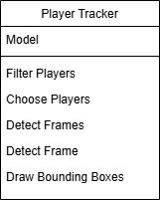**Justification:** The YOLO model is pre-trained and is great for multi-object identification. Especially given that it can use bounding box regression and class prediction in one step.

For player identification, it will detect objects other than the player so I will need to filter out what I want. Thus, I will loop over all the detected objects and keep the ones that are humans. On court, there may be humans who are not players (e.g. spectators or ball boys) so I can uniquely identify the players by the two humans that are closest to the court’s key points. As such, I will loop over each player, store their track id and the minimum distance to the court key points; choose the two players with the smallest distances. Lastly, I will draw bounding boxes around the players and extract the coordinates of the centre of the box in that frame.

**Justification:** Some of the detected people are not relevant to the match although the YOLO model detects everything in the frame. By filtering out only the players, the algorithm facilitates straightforward player referencing.

### Filter Players

The player detections are filtered to only include the players that are on the court based on the first frame. It uses the choose_players function to determine which players are on the court.

**Justification:** Only coordinates of the tennis players will be extracted which is required for statistical analysis.

**Pseudocode:**

FUNCTION FilterPlayers (self, court_keypoints, player_detections):

CALL choose_players with court_keypoints and the first frame's player detections

INITIALISE an empty list for filtered player detections

FOR each player dictionary in player_detections:

FILTER the player dictionary to only include chosen players

APPEND the filtered player dictionary to the list of filtered player detections

RETURN filtered player detections

### Choose Players

Determines which players are on the court by calculating the distance between each player's bounding box centre and the court keypoints. It selects the two players with the smallest distances to the court keypoints.

**Justification:** Distance-based filtering will eliminate the irrelevant humans on the frame. What’s more, by obtaining the IDs of the players in the first frame, the same players can be referenced without updates. There will be no recalculation of the players in every frame which will increase processing speed.

**Pseudocode:**

FUNCTION ChoosePlayers(self, court_keypoints, player_dict):

INITIALISE an empty list for distances

FOR each player in player_dict:

CALCULATE the centre of the player's bounding box

INITIALISE min_distance to infinity

FOR each court keypoint:

CALCULATE the distance between the player's centre and the court keypoint

IF the distance is smaller than min_distance:

UPDATE min_distance with the new distance

APPEND the player's track ID and min_distance to the distances list

SORT the distances list by the distance

RETURN the track IDs of the two players with the smallest distances

### Detect Frames

Detects players in each frame of the video. It can optionally read from a stub file if provided, or save the detections to a stub file.

**Justification:** The detect_frame is called for each frame when it is iterated over. With a stub file, if detection has already been performed, I can load precomputed results. Thus, the model would not have to run again on the input video which would save computational resources and time.

**Pseudocode:**

FUNCTION detect_frames (self, frames, read_from_stub=False, stub_path=None):

INITIALISE an empty list for player detections

IF read_from_stub is True and stub_path is not None:

OPEN the stub file in read-binary mode

RETURN the loaded player detections from the file

FOR each frame in frames:

PERFORM object detection on the frame

APPEND the detected player dictionary to player detections

IF stub_path is not None:

OPEN the stub file in write-binary mode

SAVE the player detections to the file

RETURN player detections

### Detect Frame

FUNCTION detect_frame(self, frame):

PERFORM object detection on the frame using the YOLO model

INITIALISE an empty dictionary for player detections

GET the class names from the detection results

FOR each detected box in the frame:

GET the track ID of the box

GET the bounding box coordinates

GET the class ID of the object

GET the class name of the object

IF the object is a person:

ADD the track ID and bounding box to the player dictionary

RETURN player dictionary

## Ball Detection Model

For ball detection, I will train a YOLO model on an Ultralytics tennis ball dataset as it is not an object class that is included in the pre-trained dataset.

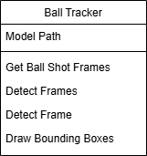**Justification:** Using the same model as for identifying the player allows me to have greater depth of understanding rather than having more breadth of models. The Ultralytics dataset is perfect since contains a diverse set of lighting conditions and ball trajectories for more generalisation.

### Get Ball Shot Frames

This function identifies the frames where the ball is hit based on changes in the ball's y-coordinate. It calculates the midpoint of the y-coordinates of the bounding boxes and function iterates through the DataFrame to detect ball hits by checking for negative to positive or positive to negative changes in delta_y. If a change is detected, it checks for consistent changes in the following frames and increments the change count if consistent changes are found. The function returns the DataFrame with the ball hit frames.

**Justification:** To calculate the speeds of the ball I need to find where the ball’s new trajectory starts from when it is hit by a player’s racket. To find this, I abuse the idea that when a player hits the ball, its y coordinate changes rapidly due to the force applied. The key indicator of a shot is a sudden reversal in direction. I ignore small fluctuations in the y coordinate so there are no false detections.

**Pseudocode:**

FUNCTION GetBallShotFrames(self, ball_positions)

EXTRACT ball positions from the dictionary

CONVERT list into a pandas DataFrame

INITIALISE 'ball_hit' column with 0

CALCULATE midpoint of y-coordinates of bounding boxes

CALCULATE rolling mean of mid_y values with a window size of 5

CALCULATE difference between consecutive rolling mean values

DEFINE minimum number of frames for a hit detection

ITERATE through the DataFrame to detect ball hits:

CHECK for negative to positive or positive to negative change in delta_y

IF change detected:

INITIALIZE change count

CHECK for consistent changes in the following frames

IF consistent changes detected:

INCREMENT change count

RETURN DataFrame with ball hit frames

### Detect Frames

This function detects ball positions in each frame of the video. If there is an available stub, it loads the ball detections from the stub file and returns them. Otherwise, it iterates through each frame, detects ball positions using the detect_frame function, and appends the detected positions to ball_detections. If stub_path is provided, it saves the ball_detections to the stub file. Finally, it returns the ball_detections.

**Pseudocode:** Same reasoning as for the player detect_frames function.

FUNCTION detect_frames (self, frames, read_from_stub=False, stub_path=None):

INITIALISE ball_detections as an empty list

IF read_from_stub is True and stub_path is provided:

LOAD ball detections from the stub file

RETURN ball_detections FOR each frame in frames:

DETECT ball positions in the frame using detect_frame

APPEND detected positions to ball_detections

IF stub_path is provided:

SAVE ball_detections to the stub file

RETURN ball_detections

### Detect Frame

This function uses the YOLO model to predict ball positions in a single frame and iterates through the detected bounding boxes. For each bounding box, it extracts the coordinates and stores them in ball_dict with the key 1. The function then returns the ball_dict.

**Pseudocode:** Same reasoning as the player detect_frame function.

FUNCTION detect_frame (self, frame):

USE the YOLO model to predict ball positions in the frame

INITIALISE ball_dict as an empty dictionary

FOR each box in the detected results:

EXTRACT bounding box coordinates

STORE bounding box coordinates in ball_dict with key 1

RETURN ball_dict

### Draw Bounding Boxes

This function draws bounding boxes around the detected balls in each frame of the video and iterates through each frame and corresponding ball_dict in video_frames and player_detections. For each bounding box, it extracts the coordinates and draws the ball ID and bounding box on the frame. The modified frame is then appended to output_video_frames.

**Pseudocode:**

FUNCTION draw_bboxes(self, video_frames, player_detections):

INITIALISE output_video_frames as an empty list

FOR each frame and ball_dict in video_frames and player_detections:

FOR each track_id and bbox in ball_dict:

EXTRACT bounding box coordinates

DRAW ball ID and bounding box on the frame

APPEND modified frame to output_video_frames

RETURN output_video_frames

## Deriving the Speed of an Object

The main benefit of bounding boxes is that I can take one of the corners’ coordinates to track the object and therefore have a means of tracking its location in each frame. Subsequently, it is possible to determine the speed of the player from the distance it moves per frame. This is possible as the frames per second (fps) of the video will be constant.

**Justification:** Here is an example:

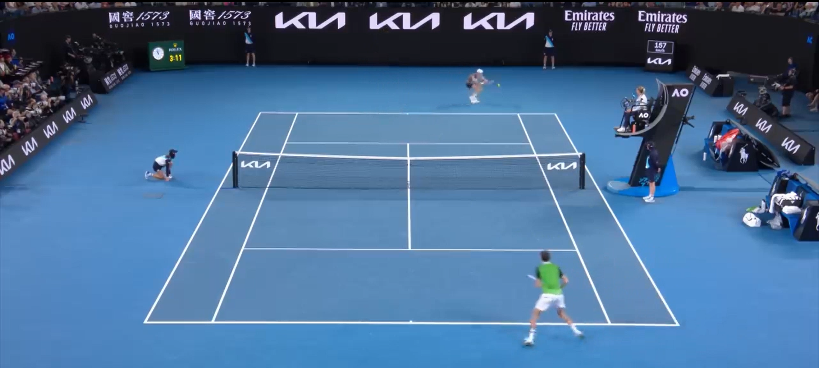

* We have a professional tennis recording at 60fps.
* The player will be at a position $\left(x,y\right)$ (derived from the centre of the bounding box) in some frame and $(x^{'},y^{'})$ in the next.
* The Euclidean distance moved is $\sqrt{{\left(x^{'}-x\right)}^{2}+{\left(y^{'}-y\right)}^{2}}$
* $60=\frac{Frames}{Time}$.
  + $∴Time=\frac{Frame}{60}=\frac{1}{60}$.
  + 1/60th of a second between each frame.

$Speed=\frac{Distance}{Time}=\frac{\sqrt{{\left(x^{'}-x\right)}^{2}+{\left(y^{'}-y\right)}^{2}}}{\frac{1}{60}}$

I will define a function that draws player statistics on each frame of the output video. It iterates over the player statistics data frame and reads the rows. It overlays the statistics on a semi-transparent background and outputs the corresponding drawn video frames.

**Justification:** A well defined statistics area keeps information organised and the transparent background permits better legibility.

**Pseudocode:**

FUNCTION DrawPlayerStatistics(output_video_frames, player_stats):

FOR each row in player_stats DataFrame:

EXTRACT player_1_shot_speed from row

EXTRACT player_2_shot_speed from row

EXTRACT player_1_speed from row

EXTRACT player_2_speed from row

EXTRACT avg_player_1_shot_speed from row

EXTRACT avg_player_2_shot_speed from row

EXTRACT avg_player_1_speed from row

EXTRACT avg_player_2_speed from row

GET the current frame from output_video_frames at index

INITIALISE shapes as a blank image with the same shape as frame

DEFINE width

DEFINE height

DEFINE start_x as frame width - constant

DEFINE start_y as frame height – constant

DEFINE end_x as start_x + width

DEFINE end_y as start_y + height

CREATE overlay as a copy of frame

DRAW a rectangle on overlay from (start_x, start_y) to (end_x, end_y) with color (0, 0, 0)

SET alpha to 0.5

BLEND overlay with frame using alpha

UPDATE output_video_frames at index with frame

DRAW the player stats on the frame:

Draw "Player 1" and "Player 2" labels

Draw shot speed stats Draw player speed stats

Draw average shot speed stats

Draw average player speed stats

RETURN output_video_frames

## A white rectangular box with black text Description automatically generatedMini Court

### Convert Meters to Pixels

Converts a distance in meters to pixels based on the court drawing width and a constant line width.

**Pseudocode:**

FUNCTION ConvertMetersToPixels(meters, conversionFactor):

CALCULATE pixels as meters * conversionFactor

RETURN pixels

### Get Coordinates

Calculates the x and y coordinates of the court to place on the video in a specified spot with buffers to the borders of the frame.

**Justification:** Adaptive placement of the widget dependent on the size of the frame of the video.

**Pseudocode:**

FUNCTION GetCoordinates(self, frame_width, frame_height):

CALCULATE court_x as (frame_width - self.drawing_rectangle_width) / 2

CALCULATE court_y as frame_height - self.drawing_rectangle_height - self.buffer

SET self.court_position to (court_x, court_y)

RETURN self.court_position

### Set Key Points

Setting the coordinates for 14 key points to the calculated values based on the court dimensions and constants.

**Pseudocode:**

FUNCTION SetKeyPoints(keypoints, coordinates):

FOR each keypoint in keypoints:

SET keypoint.x to coordinates.x

SET keypoint.y to coordinates.y

RETURN keypoints

### Draw Mini Court

Draws the mini court on each frame in a list of frames by drawing the background rectangle and court lines.

**Pseudocode:**

FUNCTION DrawMiniCourt(frame, courtDimensions, courtPosition):

EXTRACT width from courtDimensions

EXTRACT height from courtDimensions

EXTRACT x from courtPosition

EXTRACT y from courtPosition

DRAW rectangle on frame with top-left corner at (x, y) and dimensions (width, height)

RETURN frame

### Convert Object Coordinates

This function converts player and ball bounding boxes to mini court coordinates based on the original court key points.

**Pseudocode:**

FUNCTION ConvertObjectCoordinates (bounding_boxes, conversionFactor):

INITIALISE mini_court_coordinates as an empty list

FOR each bounding_box in bounding_boxes:

CONVERT bounding_box coordinates using conversionFactor

APPEND converted coordinates to mini_court_coordinates

RETURN mini_court_coordinates

### Draw Points

Draws points on the mini court for each frame based on the given positions.

**Pseudocode:**

FUNCTION DrawPoints(frame, points, color, radius):

FOR each point in points:

DRAW circle on frame at point coordinates with specified color and radius

RETURN frame

## Key Variables

Identified and justified the key variables/data structures/classes (as appropriate to the proposed solution) justifying and explaining any necessary validation.

|  |  |  |  |
| --- | --- | --- | --- |
| **Variable** | **Data Type** | **Description** | **Justification** |
| Insert_video_path | String | The path file of the video that has been chosen for analysis | Necessary for retrieval of the video for loading |
| Video_frames | List of numpy.ndarray | List of frames read from the input video | Necessary for further processing such as in player and ball detection |
| Player_tracker | Instance of PlayerTracker | This object is responsible for detecting players in the video frames using the pre-trained YOLO model | Necessary for assessing position of players and identification of the actual players |
| Ball_tracker | Instance of BallTracker | This object is responsible for detecting the ball in the video frames using a pre-trained model. | Necessary for tracking of the ball’s trajectory |
| Player_detections | List of dictionaries with keys such as bbox | This variable holds the detection results for players in each frame, which are used for further analysis and processing | Stores structured player information, allowing consistent tracking and filtering for analysis |
| Ball_detections | List of dictionaries with keys such as bbox | This variable holds the detection results for the ball in each frame | Stores structured ball information, allowing consistent tracking and further analysis |
| Court_line_detector | Instance of CourtLineDetector | This object is responsible for detecting court lines and key points in the video frames using the ResNet-50 pre-trained model | Necessary for transforming the perspective in the video to a 2D top-down view |
| Court_keypoints | List of tuples (x, y) | This variable holds the key points’ coordinates of the court detected in the first frames | The key points are necessary for filtering player detections and for further analysis |
| Mini_court | Instance of MiniCourt | This object is responsible for converting the detected bounding boxes of players and the ball into coordinates on a mini court representation | Necessary for converting the positions of the players and ball onto the mini court positions |
| Ball_shot_frames | List of integers | This variable holds the indices of frames where the ball is hit, which is important for analysing player performance and game events | Necessary for calculations of average ball speeds with the ball hit event to correctly assign the distance travelled per unit time |
| Player_mini_court_positions | List of dictionary with keys such as player_id, position | This variable holds the positions of players on the mini court, which are used for visualising player movements and analysing their strategies | Necessary for plotting the player movement on the court diagram and calculation of average speeds |
| Ball_mini_court_positions | List of dictionary with keys such as frame_num, position | This variable holds the positions of the ball on the mini court | Necessary for visualising ball trajectories on the court diagram and calculation of average speeds |
| Player_stats_data | List of dictionaries with keys such as frame_num, player_1_number_of_shots, player_1_total_shot_speed | This variable holds all of the combined statistics data for players | Encapsulates all of the necessary statistics about the players which are included in other functions such as court diagrams |

## Testing

Identified and justified the test data to be used during the iterative development of the solution.

Identified and justified any further data to be used in the post-development phase.

### Iterative Development Phase

Throughout development, I will test individual functions with possible test data and utilise debugging to slowly step through.

**Justification:** With this method, I can catch type, syntax and other forms of bugs. Furthermore, I will implement a frame count on each frame such that I can identify particular moments which may have caused issue.

To validate the machine learning models, I will use a subset of the dataset that represents the various scenarios the model will encounter and ensure the test data includes both positive and negative examples (e.g. frames with and without ball hits). I can then check the loss and adjust appropriately.

**Justification:** Since machine learning models are black box algorithms, it is impossible to test the inside workings. Thus, we can only interpret the precision of the output.

### Post Development Phase

I need to test the user’s main input: to allow the user to upload videos. The action of pressing the Tkinter buttons and opening a file explorer window has to be tested. I also have to validate that the file at input_video_file is in the right format (mp4). Thus, I can try feeding in other file types to test that an alternate file is requested if erroneous.

Another potential input is through the video player to play back output labelled video. The other only usability features are the video controls which need to be manually tested to see if they are foolproof and won’t fail under multiple requests. I have constructed a table of inputs to test the usability features:

|  |  |  |
| --- | --- | --- |
| **Test** | **Input** | **Expected Outcome** |
| Window | Fullscreen button | The user interface expands to maximum size |
|  | Exit button | The application closes |
| Video Slider | Mouse click on the far left of the slider | Video play from the beginning |
|  | Mouse click in the middle of the slider | Video plays from the position selected as a ratio of the video |
|  | Mouse click on the far right of the slider | Video play from the end and stops |
|  | Drag the slider from start to end | Video plays from the end and stops |
|  | Drag the slider from arbitrary point in the middle to arbitrary point | Video plays initial point and moves to new arbitrary point |
| Play Button | Press play button | The video starts playing from the beginning |
|  | Pressing play button multiple times | The video continues playing and is not affected after the first press |
| Pause Button | Press pause button | The video stops playing and pauses at a select frame |
|  | Press pause and then play button | The video stops playing and then starts playing again from where it was paused |
| Stop Button | Press stop button | The video stops and pauses on the first frame of the video |
|  | Press play button and then stop button | Video plays and then the video |
|  | Press pause button and then stop button | Video pauses at the frame where it was playing last and then goes to the start of the video and pauses |
| Select File Button | Press select file button | Opens a file dialog |
| File Dialog | Press folder | Enters the directory and displays all of the subdirectories |
|  | Select video file | Passes the video file path to the main video processing function and starts playing the output video when it has been produced |
|  | Select non-compatible file of wrong format | The file dialog prompts the user to re-select and alerts an error message that an erroneous file type has been chosen |
|  | Select video of large file size | The video is still processed and the result is displayed |

After development, I will also be using different online videos as input to help identify any gaps in the model's performance and areas for improvement. A larger and more diverse dataset will provide a better assessment of the machine learning models’ robustness so I would use real-world data.

|  |  |
| --- | --- |
| **Video** | **Justification** |
| ATP Video (Standard Top Down Competition Video) | Confirms the model with data that is similar to the training dataset |
| Video where a player is outside of the camera frame | Tests whether the model can deal with missing subjects |
| Clay video with people walking past | Evaluates if the model can select the correct players within a cluttered environment and different court type |
| Low angle grass court | Check robustness against camera angle outside of data set and different surface. |

At the end, I will ask my stakeholders whether the product meets their requirements and ask for further improvements or suggestions.

# Development

Provided evidence of each stage of the iterative development process for a coded solution relating this to the breakdown of the problem from the analysis stage and explaining what they did and justifying why.

Provided evidence of prototype versions of their solution for each stage of the process.

The solution will be well structured and modular in nature.

Code will be annotated to aid future maintenance of the system.

All variables and structures will be appropriately named.

Throughout the whole process, I have continuously pushed my project versions on Github (<https://github.com/yuyaox122/Tennis_ML_Analysis>). The version control software has helped me to iteratively develop my project and keep track of changes.

## Stage 1: Court Keypoints Detection

### Model Training

Importing required libraries:

import torch

from torch.utils.data import Dataset, DataLoader

from torchvision import models, transforms

import json

import cv2

import numpy as np

To allow for faster training I used a GPU if it was available on Google Colab.

**Justification:** Therefore, I did not have to train on my local device which is slow.

# If there's a GPU available we'll use it otherwise we'll use the CPU

device = torch.device("cuda" if torch.cuda.is_available() else "cpu")

I found a dataset on Github (<https://github.com/yastrebksv/TennisCourtDetector>) as outlined in the design section and here I retrieved it from google drive and unzipped it.

# Retrieves zipped dataset from google drive

*!*wget *--*header="Host: drive.usercontent.google.com" -c -O 'tennis_court_det_dataset.zip'

*!*unzip tennis_court_det_dataset.zip

The images have 1280x720 resolution and the PointsDataset class preprocesses the images before they are fed into the neural network. The images are converted to a Python Imaging Library image and resized to 244x244.

**Justification:** It is the appropriate aspect ratio for the model which was defined for the transformation pipeline.

class PointsDataset(Dataset):

    def __init__(self, img_dir, data_file):

        self.img_dir = img_dir

        # Reads dictionary from json file

        with open(data_file, "r") as f:

            self.data = json.load(f)

# Transforms data into right size

        self.transform = transforms.Compose([

            transforms.ToPILImage(),

            transforms.Resize((224, 224)),

            transforms.ToTensor(),

            # Normalise pixel values for easier training

            transforms.Normalize(mean=[0.485, 0.456, 0.406], std=[0.229, 0.224, 0.225])

        ])

    def __len__(self):

        return len(self.data)

    def __getitem__(self, idx):

        # Given an index, returns the image and the points

        item = self.data[idx]

        img = cv2.imread(f"{self.img_dir}/{item['id']}.png")

        height, width = img.shape[:2]

        img = cv2.cvtColor(img, cv2.COLOR_BGR2RGB)

        img = self.transform(img)

        # Array becomes 1D

        points = np.array(item['kps']).flatten()

        points = points.astype(np.float32)

        # Scale points to 224x224

        points[::2] *= 224 / width

        points[1::2] *= 224 / height

        return img, points

The __getitem__ method allows for retrieval of a single data point given an index. The key points associated with the image are extracted from the item dictionary and converted into a NumPy array. The flatten method is used to convert the array into a 1D array, and the data type is changed to float32.

**Justification:** The defined transformation is to allow for compatibility with PyTorch. The key points are then scaled to match the 224x224 dimensions of the transformed image.

# Splitting data into training and validation

training_dataset = PointsDataset("data/images", "data/data_train.json")

validation_dataset = PointsDataset("data/images", "data/data_val.json")

training_loader = DataLoader(training_dataset, batch_size=32, shuffle=True)

validation_loader = DataLoader(validation_dataset, batch_size=32, shuffle=True)

# Load pre-trained model

model = models.resnet50(pretrained=True)

# Fine-tune model by changing the last layer to output x and y coordinates for the 14 keypoints

model.fc = torch.nn.Linear(model.fc.in_features, 14 * 2)

# Move model to device

model = model.to(device)

The dataset is split into 75% for training and 25% for validation. Here, I have chosen to use mean squared error as my loss function and an Adam optimiser. I run through a set number of epochs (20), where I propagate backwards. To keep track of the improvement of the model, I printed the loss at every 10 epochs.

**Justification:** The choice of 32 as a batch size is a common choice which strikes a middle ground between performance and memory usage.

# Define loss function and optimiser

criterion = torch.nn.MSELoss()

optimiser = torch.optim.Adam(model.parameters(), lr=0.001)

epochs = 20

for epoch in range(epochs):

    for i, (imgs, points) in enumerate(training_loader):

        imgs = imgs.to(device)

        points = points.to(device)

        # Zero gradients before each iteration

        optimiser.zero_grad()

        # Model outputs the predicted points

        outputs = model(imgs)

        # Calculate loss

        loss = criterion(outputs, points)

        # Backpropagation

        loss.backward()

        optimiser.step()

        if (i % 10) == 0:

            print(f"Epoch {epoch}, Iteration {i}, Loss: {loss.item()}")

# Save model

torch.save(model.state_dict(), "court_points_model.pth")

### Key Point Detection

In court_line_detector.py, I defined a CourtLineDetector class that would be initialised as a Restnet-50 model with the pretrained state dictionary. Upon initialisation, it also creates a transform where the input image is converted to a PIL image and then normalised.

**Justification:** This is consistent with the transformation pipeline outlined before and standardises the data to a tensor for PyTorch.

class CourtLineDetector:

    def __init__(self, model_path):

        self.model = models.resnet50(pretrained=True)

        self.model.fc = torch.nn.Linear(self.model.fc.in_features, 14*2)

        # Map model to CPU

        self.model.load_state_dict(torch.load(model_path, map_location='cpu'))

        self.transform = transforms.Compose([

            transforms.ToPILImage(),

            transforms.Resize((224, 224)),

            # Transform the image to a tensor and normalize it

            transforms.ToTensor(),

            # Normalize the image with mean and standard deviation values

            transforms.Normalize(mean=[0.485, 0.456, 0.406], std=[0.229, 0.224, 0.225])

        ])

I fed in the first frame of the video to predict the key points of the court.

**Justification:** The key points only need to be found once (assuming that the camera angle is the same).

Gradient calculation is disabled.

**Justification:** To reduce computational overhead and memory usage since inference does not require backpropagation.

    def predict(self, image):

        # Convert the image from BGR to RGB color space

        image_rgb = cv2.cvtColor(image, cv2.COLOR_BGR2RGB)

        # Apply the transformations and add a batch dimension

        image_tensor = self.transform(image_rgb).unsqueeze(0)

        # Disable gradient calculation for inference

        with torch.no_grad():

            # Get the model's predictions

            outputs = self.model(image_tensor)

        # Convert the output tensor to a numpy array

        keypoints = outputs.squeeze().cpu().numpy()

        # Get the original image dimensions

        original_h, original_w = image.shape[:2]

        # Scale the keypoints to the original image dimensions

        print(keypoints)

        print(keypoints[::2])

        print(keypoints[1::2])

        keypoints[::2] *= original_w / 224.0

        keypoints[1::2] *= original_h / 224.0

        return keypoints

Iterating over the keypoints, it draws the keypoint index near the keypoint using cv2.putText. Draws a circle at the keypoint location using cv2.circle. Returns the image with the drawn keypoints.

**Justification:** The OpenCV library has accessible functions to draw directly onto each frame. These can then be combined back together to form the final video.

    def draw_keypoints(self, image, keypoints):

    # Plot keypoints on the image

        for i in range(0, len(keypoints), 2):

            # Get the x and y coordinates of the keypoint

            x = int(keypoints[i]) + 10

            y = int(keypoints[i+1])

            # Draw the keypoint index near the keypoint

            cv2.putText(image, str(i//2), (x, y - 10), cv2.FONT_HERSHEY_COMPLEX, 0.5, (0, 0, 255), 2)

            # Draw a circle at the keypoint location

            cv2.circle(image, (x, y), 5, (0, 0, 255), -1)

        return image

Initialises an empty list to hold the output video frames. For each frame, it calls the draw_keypoints function to draw the keypoints on the frame. Appends the frame with the drawn keypoints to the output list. Returns the list of video frames with the drawn keypoints.

    def draw_keypoints_on_video(self, video_frames, keypoints):

        # Initialise a list to hold the output video frames

        output_video_frames = []

        # Iterate over each frame in the video

        for frame in video_frames:

            # Draw keypoints on the current frame

            frame = self.draw_keypoints(frame, keypoints)

            # Append the frame with keypoints to the output list

            output_video_frames.append(frame)

        return output_video_frames

### Review

The development will show review at all key stages in the process.

The notebook court_points_training.ipynb trains a neural network to detect keypoints in tennis court images. It defines a custom dataset class to load images and their corresponding keypoints. Data augmentation and preprocessing are applied using TorchVision transforms. The training and validation datasets are loaded using DataLoader. The training loop iterates over multiple epochs, updating model parameters and validating the model's performance after each epoch. The trained model is saved to a file for future use.

The court_line_detector.py script is designed to process tennis court images and videos by detecting and drawing keypoints on them. The script includes functions to scale keypoints according to the original image dimensions and to visualize these keypoints on both images and video frames

### Criteria Fulfilled

Train model to identify the key points of the tennis court

Pre-processed datasets for machine learning models

### Validation

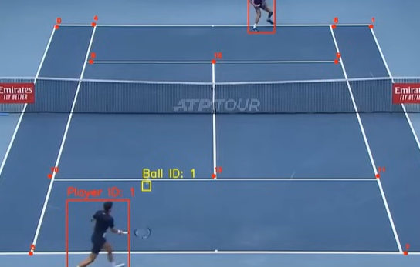There will be evidence of validation for all key elements of the solution.

A visual inspection demonstrates that although some points are offset by a margin of error, the model is able to mark the key points with a high degree of accuracy.

**Justification:** A quick and intuitive test mimicking the final output that will be seen by the end user.

A print of the 14 output coordinates detected:

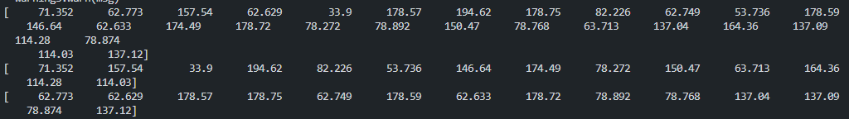

The model is tested with the validation dataset (25% of the original dataset) and its loss is calculated.

**Justification:** In machine learning, it is a standard procedure to separate a sample of data for an unbiased evaluation of the fitted model. A loss calculation quantifies the performance of the model in an objective measure.

model.eval()

validation_loss = 0.0

with torch.no_grad():

    for imgs, points in validation_loader:

        imgs = imgs.to(device)

        points = points.to(device)

        outputs = model(imgs)

        loss = criterion(outputs, points)

        validation_loss += loss.item()

validation_loss /= len(validation_loader)

print(f"Validation Loss: {validation_loss}")

## Stage 2: Player Detection

I am using an object-oriented approach such that I can easily decompose the problem and maintain modularity which promotes consistency and reusability of code. The file player_tracker.py would contain the PlayerTracker class that handles the player detection model. The YOLO model is imported through its file path in the constructor.

class PlayerTracker:

    def __init__(self, model_path):

        self.model = YOLO(model_path)

The following function selects from the humans that are detected in the first frame and stores the track_id of the two humans that are closest to the court key points.

**Justification:** By assumption, these two are the most likely to be the two players in a tennis match.

Iterate through each player’s data in player_detections and if the trackid matches one of the players that has been selected. These are then added onto the filtered_player_detections and returned.

    Def filter_players(self, court_keypoints, player_detections):

        # Choose the players that are on the court from the first frame

        chosen_players = self.choose_players(court_keypoints, player_detections[0])

        filtered_player_detections = []

        for player_dict in player_detections:

            filtered_player_dict = {trackid: bbox for trackid, bbox in player_dict.items() if trackid in chosen_players}

            filtered_player_detections.append(filtered_player_dict)

        return filtered_player_detections

To choose the players, a variable called min_distance is declared and set to infinity as a maximum placeholder value. It represents the distance the person is to its closest key point. Looping through the player_dict, if the distance from the centre of the person’s bounding box to the keypoint is smaller than min_distance, it is replaced. The distances are then sorted by min_distance.

**Justification:** By sorting the distances dictionary, we can obtain the trackids in ascending order of minimum_distance, from which we can extract the two closest people to the court which are assumed to be the players.

    def choose_players(self, court_keypoints, player_dict):

        distances = []

        # Loop through the players in the player dictionary

        for track_id, bbox in player_dict.items():

            player_centre = get_centre_of_bbox(bbox)

            min_distance = float('inf')

            for i in range(0 , len(court_keypoints), 2):

                # Loop through the x and y coordinates of the court keypoints

                court_keypoint = (court_keypoints[i], court_keypoints[i+1])

                distance = measure_distance(player_centre, court_keypoint)

                if distance < min_distance:

                    min_distance = distance

            # For each player, store the track id and the minimum distance to the court keypoints

            distances.append((track_id, min_distance))

        distances.sort(key=lambda x: x[1])

        # Choose the two players with the smallest distances to the court keypoints

        chosen_players = [distances[0][0], distances[1][0]]

        return chosen_players

The stub is loaded if there is one at the sub path as it is much faster than processing the video again. However, if there isn’t a new stub is created by calling detect_frame repeatedly. This stub is then dumped using pickle at the stub_path.

Def detect_frames(self, frames, read_from_stub=False, stub_path=None):

        player_detections = []

        # If the player detections are read from a stub file, load the detections from the file

        if read_from_stub and stub_path is not None:

            with open(stub_path, “rb”) as f:

                return pickle.load(f)

        for frame in frames:

            # Perform object detection on the frame

            player_dict = self.detect_frame(frame)

            player_detections.append(player_dict)

        # Save the player detections to a stub file

        if stub_path is not None:

            with open(stub_path, “wb”) as f:

                pickle.dump(player_detections, f)

        return player_detections

    def detect_frame(self, frame):

        # Perform object detection on the frame

        results = self.model.track(frame, persist=True)[0]

        id_name_dict = results.names

        player_dict = {}

        # Loop through the boxes in the frame

        for box in results.boxes:

            track_id = int(box.id.tolist()[0])

            result = box.xyxy.tolist()[0]

            object_cls_id = box.cls.tolist()[0]

            # Get the class name of the object

            object_cls_name = id_name_dict[object_cls_id]

            # Check if the object is a person

            if object_cls_name == “person”:

                player_dict[track_id] = result

        return player_dict

The detect_frames calls detect_frame on each individual frame. In detect_frame, the YOLO model is used and the objects are found. Then, when looping through all of the objects, extract the assigned class name. If it is a person, then we append it to the player_dict for further selection of the players.

**Justification:** This approaches player detection in a frame by frame basis and groups up all of the collected data in player_dict for encapsulation.

    def draw_bboxes(self, video_frames, player_detections):

        output_video_frames = []

        for frame, player_dict in zip(video_frames, player_detections):

            for track_id, bbox in player_dict.items():

                x1, y1, x2, y2 = bbox

                # Draw the bounding box on the frame

                cv2.putText(frame, f"Player ID: {track_id}", (int(bbox[0]), int(bbox[1] - 10)), cv2.FONT_HERSHEY_COMPLEX, 0.9, (0, 0, 255), 2)

                cv2.rectangle(frame, (int(x1), int(y1)), (int(x2), int(y2)), (0, 0, 255), 2)

            output_video_frames.append(frame)

        return output_video_frames

For each player stored in the player dictionary, the bounding box is drawn using the x and y coordinates given. This is then added to the frame of the video along with the player’s track_id next to it.

**Justification:** The display of player id allows for the user to identify in future features, which player a statistic is referring to.

### Review

The PlayerTracker class is able to import the pre-trained model and filter out the two tennis players from the ‘person’ class of objects detected in each frame. It is then able to draw on bounding boxes around two players along with an unique ID. These written frames are then returned from the functions.

### Criteria Fulfilled

Train object detection models that can identify the position of the players

### Validation

I printed out the detection processing and compared individual frames to check whether the model was working correctly.

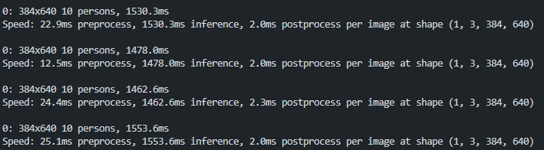

The player dictionary:

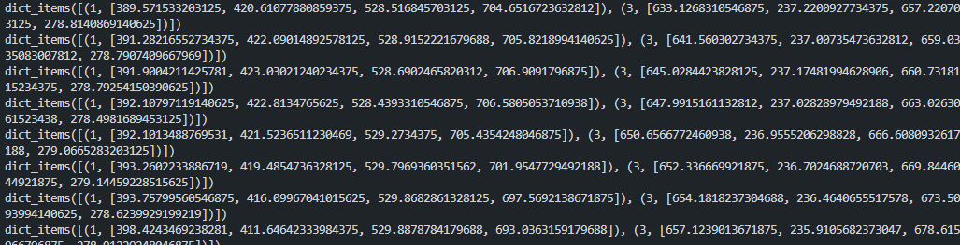

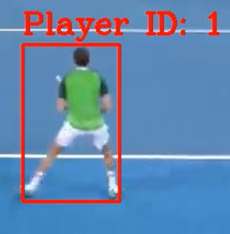I also watched over the output video for various sample videos and inspected whether the bounding boxes were fitted correctly around the players and not around the other persons.

## Stage 3: Ball Detection Model

Once again, I used Google Colab’s free resources and found a dataset on Roboflow that had tennis balls under movement.

%pip install roboflow

%pip install ultralytics

from roboflow import Roboflow

rf = Roboflow(api_key="API-KEY ")

project = rf.workspace("viren-dhanwani").project("tennis-ball-detection")

version = project.version(6)

dataset = version.download("yolov5")

I found that after testing with various YOLO models, that the most effective was YOLOv5. Similar to previously, I split the data into training, testing and validation folders.

**Justification:** As explained before, validation is necessary to quantify the accuracy of the model.

import shutil

shutil.move("tennis-ball-detection-6/train",

            "tennis-ball-detection-6/tennis-ball-detection-6/train"

            )

shutil.move("tennis-ball-detection-6/test",

            "tennis-ball-detection-6/tennis-ball-detection-6/test"

            )

shutil.move("tennis-ball-detection-6/valid",

            "tennis-ball-detection-6/tennis-ball-detection-6/valid"

            )

*!*yolo task=detect mode=train model=yolov5l6u.pt data={dataset.location}/data.yaml epochs=100 imgsz=640

### Remedial Action - Interpolation Research

Provided evidence of any failed tests and the remedial actions taken with full justification for any actions taken.

An extremely difficult issue regarding ball detection was the blurriness of individual frames. The tennis ball travels at high speeds (up to 250km/h) which cannot be captured clearly by a typical 60fps or lower cameras.

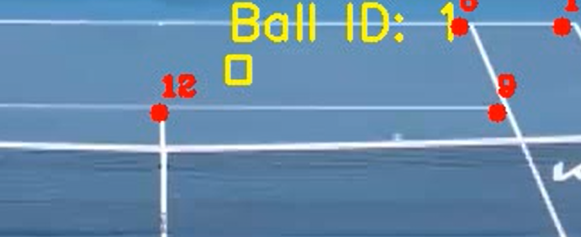

As shown above, the ball is sometimes not detected. Professional cameras could be used to improve accuracy. To make up for the missing frames, an interpolation function is required.

**Justification:** Interpolation would allow those who have sub-optimal recording conditions to still have results by sacrificing accuracy.

#### Interpolate Ball Positions Function

To fix this issue, I added an interpolation function to the class. Taking a list of ball positions as a parameter, it will interpolate any missing values.

**Pseudocode:**

FUNCTION InterpolateBallPositions(self, ball_positions):

EXTRACT ball positions from the dictionary

CONVERT list of dictionaries to a pandas DataFrame

INTERPOLATE missing values in the DataFrame

FILL remaining missing values with the last valid value

CONVERT DataFrame back to a list of dictionaries

RETURN ball positions

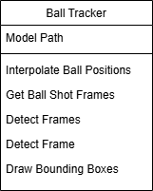

Figure : Updated Ball Tracker Class

### Ball Tracker Class

I initialise the ball detection model with its file path.

Class BallTracker:

    def __init__(self, model_path):

        # Initialise the YOLO model with the given model path

        self.model = YOLO(model_path)

The interpolate_ball_positions function takes a list of dictionaries containing ball positions and interpolates any missing values. It first extracts the ball positions, converts them into a pandas DataFrame, and then uses the interpolate method to fill in missing values. Any remaining missing values are filled using the last valid value. Finally, it converts the DataFrame back to the original list of dictionaries format and returns the interpolated ball positions.

**Justification:** Pandas data frames are great for handling large amounts of data in one variable and allow for slicing.

Def interpolate_ball_positions(self, ball_positions):

        # Extract the ball positions from the dictionary

        ball_positions = [x.get(1, []) for x in ball_positions]

        # Convert the list of dictionaries to a pandas DataFrame

        df_ball_positions = pd.DataFrame(ball_positions, columns=[‘x1’, ‘y1’, ‘x2’, ‘y2’])

        # Interpolate the missing values in the DataFrame

        df_ball_positions = df_ball_positions.interpolate()

        # Fill the remaining missing values with the last valid value

        df_ball_positions = df_ball_positions.bfill()

        # Convert the DataFrame back to a list of dictionaries

        ball_positions = [{1: x} for x in df_ball_positions.to_numpy().tolist()]

        return ball_positions

This function identifies frames where the ball is hit based on changes in its vertical position. It then calculates the midpoint of the ball’s vertical position and its rolling mean. The difference between consecutive rolling mean values is used to detect changes in direction. If a significant change in direction is detected within a specified number of frames, it marks the frame as a ball hit. The function returns the DataFrame with an additional column indicating ball hit frames.

**Justification:** The rolling mean would smooth out any noise and the difference between consecutive rolling means highlights sudden changes in direction where a hit would exist.

Def get_ball_shot_frames(self, ball_positions):

        # Extract the ball positions from the dictionary

        ball_positions = [x.get(1, []) for x in ball_positions]

        # Convert the list into a pandas DataFrame

        df_ball_positions = pd.DataFrame(ball_positions, columns=[‘x1’, ‘y1’, ‘x2’, ‘y2’])

        # Initialise the ‘ball_hit’ column with 0

        df_ball_positions[‘ball_hit’] = 0

        # Calculate the midpoint of the y-coordinates of the bounding boxes

        df_ball_positions[‘mid_y’] = (df_ball_positions[‘y1’] + df_ball_positions[‘y2’]) / 2

        # Calculate the rolling mean of the mid_y values with a window size of 5

        df_ball_positions[‘mid_y_rolling_mean’] = df_ball_positions[‘mid_y’].rolling(window=5, min_periods=1, center=False).mean()

        # Calculate the difference between consecutive rolling mean values

        df_ball_positions[‘delta_y’] = df_ball_positions[‘mid_y_rolling_mean’].diff()

        # Define the minimum number of frames for a hit detection

        minimum_change_frames_for_hit = 25

        # Iterate through the DataFrame to detect ball hits

        for I in range(1, len(df_ball_positions) – int(minimum_change_frames_for_hit * 1.2)):

            # Check for a negative to positive or positive to negative change in delta_y

            negative_position_change = df_ball_positions[‘delta_y’].iloc[i] > 0 and df_ball_positions[‘delta_y’].iloc[I + 1] < 0

            positive_position_change = df_ball_positions[‘delta_y’].iloc[i] < 0 and df_ball_positions[‘delta_y’].iloc[I + 1] > 0

            if negative_position_change or positive_position_change:

                change_count = 0

                # Check for consistent changes in the following frames

                for change_frame in range(I + 1, I + int(minimum_change_frames_for_hit * 1.2) + 1):

                    negative_position_change_following_frame = df_ball_positions[‘delta_y’].iloc[i] > 0 and df_ball_positions[‘delta_y’].iloc[change_frame] < 0

                    positive_position_change_following_frame = df_ball_positions[‘delta_y’].iloc[i] < 0 and df_ball_positions[‘delta_y’].iloc[change_frame] > 0

                    if negative_position_change and negative_position_change_following_frame:

                        change_count += 1

                    elif positive_position_change and positive_position_change_following_frame:

                        change_count += 1

                # Mark the frame as a ball hit if the change count exceeds the threshold

                if change_count > minimum_change_frames_for_hit – 1:

                    df_ball_positions[‘ball_hit’].iloc[i] = 1

        # Get the frame numbers where ball hits are detected

        frame_nums_with_ball_hits = df_ball_positions[df_ball_positions[‘ball_hit’] == 1].index.tolist()

        return frame_nums_with_ball_hits

If the model has already been trained and there is a stub, then used the pre-trained model. If not reading from a stub, the function iterates over the provided frames list. For each frame, it calls the detect_frame function to detect the ball in the frame. The result, player_dict, is a dictionary containing the bounding box coordinates of the detected ball. This dictionary is appended to the ball_detections list. If a stub_path is provided, the function saves the computed ball detections to the specified file. Finally, the function returns the ball_detections list, which contains the ball detection results for all frames.

**Justification:** Same reasoning as before to use a stub – it saves computation resources.

A confidence threshold of 0.15 is set.

**Justification:** A lower threshold ensures that balls compressed due to their high speeds are not missed.

    Def detect_frames(self, frames, read_from_stub=False, stub_path=None):

        ball_detections = []

        # If read_from_stub is True, load ball detections from the stub file

        if read_from_stub and stub_path is not None:

            with open(stub_path, ‘rb’) as f:

                ball_detections = pickle.load(f)

            return ball_detections

        # Detect ball positions in each frame

        for frame in frames:

            player_dict = self.detect_frame(frame)

            ball_detections.append(player_dict)

        # Save ball detections to the stub file if stub_path is provided

        if stub_path is not None:

            with open(stub_path, ‘wb’) as f:

                pickle.dump(ball_detections, f)

        return ball_detections

    def detect_frame(self, frame):

        # Use the YOLO model to predict ball positions in the frame

        results = self.model.predict(frame, conf=0.15)[0]

        ball_dict = {}

        # Extract the bounding box coordinates for each detected ball

        for box in results.boxes:

            result = box.xyxy.tolist()[0]

            ball_dict[1] = result

        return ball_dict

This function draws bounding boxes around detected balls in a sequence of video frames. It iterates over each frame and its corresponding ball detection dictionary. For each detected ball, it draws a rectangle around the ball’s bounding box and adds a label with the ball’s ID. The annotated frames are collected into a list, which is returned as the output. This function uses OpenCV for drawing the bounding boxes and text on the frames.

    Def draw_bboxes(self, video_frames, player_detections):

        output_video_frames = []

        # Draw bounding boxes on each frame

        for frame, ball_dict in zip(video_frames, player_detections):

            for track_id, bbox in ball_dict.items():

                x1, y1, x2, y2 = bbox

                # Draw the ball ID and bounding box on the frame

                cv2.putText(frame, f”Ball ID: {track_id}”, (int(bbox[0]), int(bbox[1] – 10)), cv2.FONT_HERSHEY_SIMPLEX, 0.9, (0, 255, 255), 2)

                cv2.rectangle(frame, (int(x1), int(y1)), (int(x2), int(y2)), (0, 255, 255), 2)

            output_video_frames.append(frame)

        return output_video_frames

### Review

The BallTracker class imports the YOLO model and provides methods to detect frames where ball hits occur, and draw bounding boxes around detected balls. The new interpolate_ball_positions method converts ball positions to a pandas DataFrame, interpolates missing values, and converts it back to a list of dictionaries. The detect_frames method repeatedly calls detect_frame, optionally reading from or saving to a stub file. The detect_frame method uses the YOLO model to predict ball positions in a single frame. Following this, the draw_bboxes method draws bounding boxes and ball IDs on each frame and returns the modified frames.

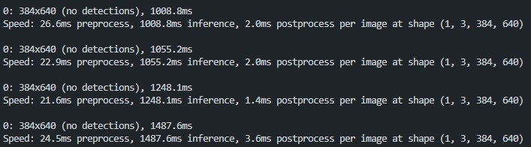

### Criteria Fulfilled

Train object detection models that can identify the position of the players

### Validation

To validate the model I used the validation mode provided by the Ultralytics library.

# Validate the model

*!*yolo task=detect mode=val model=yolov5l6u.pt data={dataset.location}/data.yaml imgsz=640

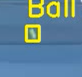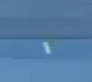A visual comparison between having interpolation and none is a distinct contrast.

Previously, during the middle of fast shots’ trajectories, there would be no bounding box. But with the introduction of interpolation, although the bounding box is not always around the ball, it is a good estimate.

## Stage 5: Performance Metrics Extraction

During development, I realised that it is easier and more convenient to draw the performance statistics on the video itself.

**Justification:** Therefore, it will not be will not be hardcoded into the user interface so fewer additional elements are needed. Additionally, it will be included if the video is downloaded in the future.

Def draw_player_stats(output_video_frames, player_stats):

    # Iterate over each row in player_stats DataFrame

    for index, row in player_stats.iterrows():

        # Extract player statistics from the current row

        player_1_shot_speed = row[‘player_1_last_shot_speed’]

        player_2_shot_speed = row[‘player_2_last_shot_speed’]

        player_1_speed = row[‘player_1_last_player_speed’]

        player_2_speed = row[‘player_2_last_player_speed’]

        avg_player_1_shot_speed = row[‘player_1_average_shot_speed’]

        avg_player_2_shot_speed = row[‘player_2_average_shot_speed’]

        avg_player_1_speed = row[‘player_1_average_player_speed’]

        avg_player_2_speed = row[‘player_2_average_player_speed’]

I initialised separate variables for each statistic that I am hoping to include and set their values to the rows of the player_stats DataFrame.

**Justification:** Separate variables improves readability for debugging.

        # Get the current frame from the output video frames

        frame = output_video_frames[index]

        shapes = np.zeros_like(frame, np.uint8)

        # Define the dimensions and position of the stats overlay

        width = 350

        height = 230

        start_x = frame.shape[1] – 380

        start_y = frame.shape[0] – 250

        end_x = start_x + width

        end_y = start_y + height

# Create a semi-transparent overlay for the stats

        overlay = frame.copy()

        cv2.rectangle(overlay, (start_x, start_y), (end_x, end_y), (0, 0, 0), -1)

        alpha = 0.5

        cv2.addWeighted(overlay, alpha, frame, 1 - alpha, 0, frame)

        output_video_frames[index] = frame

I defined the width and height along with the coordinates of the overlay. Then, a black rectangle on the overlay serves as the background for the stats. Blending the overlay with the original frame using cv2.addWeighted to create a semi-transparent effect.

**Justification:** Using frame.shape allows automatic positioning irrespective of resolution. There is potential for scalability by expanding the rectangle size.

        # Draw the player stats on the frame

        text = "     Player 1     Player 2"

        output_video_frames[index] = cv2.putText(output_video_frames[index], text, (start_x + 80, start_y + 30), cv2.FONT_HERSHEY_SIMPLEX, 0.6, (255, 255, 255), 2)

        # Draw shot speed stats

        text = "Shot Speed"

        output_video_frames[index] = cv2.putText(output_video_frames[index], text, (start_x + 10, start_y + 80), cv2.FONT_HERSHEY_SIMPLEX, 0.45, (255, 255, 255), 1)

        text = f"{player_1_shot_speed:.1f} km/h    {player_2_shot_speed:.1f} km/h"

        output_video_frames[index] = cv2.putText(output_video_frames[index], text, (start_x + 130, start_y + 80), cv2.FONT_HERSHEY_SIMPLEX, 0.5, (255, 255, 255), 2)

        # Draw player speed stats

        text = "Player Speed"

        output_video_frames[index] = cv2.putText(output_video_frames[index], text, (start_x + 10, start_y + 120), cv2.FONT_HERSHEY_SIMPLEX, 0.45, (255, 255, 255), 1)

        text = f"{player_1_speed:.1f} km/h    {player_2_speed:.1f} km/h"

        output_video_frames[index] = cv2.putText(output_video_frames[index], text, (start_x + 130, start_y + 120), cv2.FONT_HERSHEY_SIMPLEX, 0.5, (255, 255, 255), 2)

        # Draw average shot speed stats

        text = "Mean Shot"

        output_video_frames[index] = cv2.putText(output_video_frames[index], text, (start_x + 10, start_y + 160), cv2.FONT_HERSHEY_SIMPLEX, 0.45, (255, 255, 255), 1)

        text = f"{avg_player_1_shot_speed:.1f} km/h    {avg_player_2_shot_speed:.1f} km/h"

        output_video_frames[index] = cv2.putText(output_video_frames[index], text, (start_x + 130, start_y + 160), cv2.FONT_HERSHEY_SIMPLEX, 0.5, (255, 255, 255), 2)

        # Draw average player speed stats

        text = "Mean Player"

        output_video_frames[index] = cv2.putText(output_video_frames[index], text, (start_x + 10, start_y + 200), cv2.FONT_HERSHEY_SIMPLEX, 0.45, (255, 255, 255), 1)

        text = f"{avg_player_1_speed:.1f} km/h    {avg_player_2_speed:.1f} km/h"

        output_video_frames[index] = cv2.putText(output_video_frames[index], text, (start_x + 130, start_y + 200), cv2.FONT_HERSHEY_SIMPLEX, 0.5, (255, 255, 255), 2)

    return output_video_frames

For each statistical row, the text is pre-written and the changing values are rounded to 1 decimal place. The numerical values are placed appropriately next to their sign holders. This is finally assigned to the correct frame and returned.

**Justification:** Rounding gets rids of excess decimals which may overlap beyond the frame.

### Criteria Fulfilled

Display of performance data

### Review

A small panel is created to display the shot and player speed as well as their averages. It fulfils the success criteria well and populates the data correctly. Moreover, the choice of a transparent background does not obstruct viewing of the tennis game.

### A screen shot of a computer AI-generated content may be incorrect.Validation

To test the functionality I created a list of dummy video frames with random or solid colour values; created a dummy player_stats DataFrame with columns corresponding to the player statistics used in the function. Then, I conducted a visual inspection to check that the panel is showcasing the right numbers.

import pandas as pd

import numpy as np

import cv2

# Create dummy video frames

output_video_frames = [np.zeros((720, 1280, 3), dtype=np.uint8) for _ in range(10)]

# Create dummy player stats DataFrame

data = {

    'player_1_last_shot_speed': [100] * 10,

    'player_2_last_shot_speed': [90] * 10,

    'player_1_last_player_speed': [10] * 10,

    'player_2_last_player_speed': [9] * 10,

    'player_1_average_shot_speed': [95] * 10,

    'player_2_average_shot_speed': [85] * 10,

    'player_1_average_player_speed': [8] * 10,

    'player_2_average_player_speed': [7] * 10,

}

player_stats = pd.DataFrame(data)

# Call the function

output_video_frames = draw_player_stats(output_video_frames, player_stats)

# Display the frames

for frame in output_video_frames:

    cv2.imshow('Frame', frame)

    cv2.waitKey(0)

cv2.destroyAllWindows()

## Stage 6: Mini Court Diagram

class MiniCourt():

    def __init__(self, frame):

        self.drawing_rectangle_width = 200

        self.drawing_rectangle_height = 400

        # Buffer between the court and the frame edges

        self.buffer = 30

        self.padding_court = 20

        # Set the position of the background rectangle

        self.set_court_background_position(frame)

        self.set_mini_court_position()

        self.set_court_drawing_key_points()

        self.set_court_lines()

    def convert_meters_to_pixels(self, meters):

        return convert_meters_to_pixel_distance(meters,

                                                constants.DOUBLE_LINE_WIDTH,

                                                self.court_drawing_width

                                            )

**Justification:** drawing_rectangle_width and drawing_rectangle_height are chosen to maintain an accurate aspect ratio while ensuring visibility within the frame. A buffer of 30 pixels ensures the court does not overlap with UI elements, improving readability.

The 14 points’ positions are defined relative to the court size. I have hard coded the position of the key points using the standard tennis court dimensions. I set these as constants as one of my utilities functions as well as functions to convert between pixels and meters.

**Justification:** Therefore, the mini-court can be adapted to difference resolutions and tennis court angles by scaling proportionally.

    def set_court_drawing_key_points(self):

        # 14 key points with x,y coordinates

        drawing_key_points = [0] * 28

        # Point 0

        drawing_key_points[0] , drawing_key_points[1] = int(self.court_start_x), int(self.court_start_y)

        # Point 1

        drawing_key_points[2] , drawing_key_points[3] = int(self.court_end_x), int(self.court_start_y)

        # Point 2

        drawing_key_points[4] = int(self.court_start_x)

        drawing_key_points[5] = self.court_start_y + self.convert_meters_to_pixels(constants.HALF_COURT_LINE_HEIGHT*2)

        # Point 3

        drawing_key_points[6] = drawing_key_points[0] + self.court_drawing_width

        drawing_key_points[7] = drawing_key_points[5]

        # Point 4

        drawing_key_points[8] = drawing_key_points[0] +  self.convert_meters_to_pixels(constants.DOUBLE_ALLY_DIFFERENCE)

        drawing_key_points[9] = drawing_key_points[1]

        # Point 5

        drawing_key_points[10] = drawing_key_points[4] + self.convert_meters_to_pixels(constants.DOUBLE_ALLY_DIFFERENCE)

        drawing_key_points[11] = drawing_key_points[5]

        # Point 6

        drawing_key_points[12] = drawing_key_points[2] - self.convert_meters_to_pixels(constants.DOUBLE_ALLY_DIFFERENCE)

        drawing_key_points[13] = drawing_key_points[3]

        # Point 7

        drawing_key_points[14] = drawing_key_points[6] - self.convert_meters_to_pixels(constants.DOUBLE_ALLY_DIFFERENCE)

        drawing_key_points[15] = drawing_key_points[7]

        # Point 8

        drawing_key_points[16] = drawing_key_points[8]

        drawing_key_points[17] = drawing_key_points[9] + self.convert_meters_to_pixels(constants.NO_MANS_LAND_HEIGHT)

        # Point 9

        drawing_key_points[18] = drawing_key_points[16] + self.convert_meters_to_pixels(constants.SINGLE_LINE_WIDTH)

        drawing_key_points[19] = drawing_key_points[17]

        # Point 10

        drawing_key_points[20] = drawing_key_points[10]

        drawing_key_points[21] = drawing_key_points[11] - self.convert_meters_to_pixels(constants.NO_MANS_LAND_HEIGHT)

        # Point 11

        drawing_key_points[22] = drawing_key_points[20] +  self.convert_meters_to_pixels(constants.SINGLE_LINE_WIDTH)

        drawing_key_points[23] = drawing_key_points[21]

        # Point 12

        drawing_key_points[24] = int((drawing_key_points[16] + drawing_key_points[18])/2)

        drawing_key_points[25] = drawing_key_points[17]

        # Point 13

        drawing_key_points[26] = int((drawing_key_points[20] + drawing_key_points[22])/2)

        drawing_key_points[27] = drawing_key_points[21]

        self.drawing_key_points = drawing_key_points

    def set_court_lines(self):

        # 8 lines with start and end points

        self.lines = [

            (0, 2),

            (4, 5),

            (6,7),

            (1,3),

            (0,1),

            (8,9),

            (10,11),

            (10,11),

            (2,3)

        ]

The key points and the line components of the court are drawn unto each frame using the OpenCV library. Circles are used to represent each keypoint. Once again, the background rectangle is transparent such that the court is made more visible and does not blend as easily with the original video.

**Justification:** By hardcoding this, I have underscored a well-defined structure for further calculations.

    def draw_court(self, frame):

        for i in range(0, len(self.drawing_key_points),2):

            x = int(self.drawing_key_points[i])

            y = int(self.drawing_key_points[i+1])

            cv2.circle(frame, (x,y), 5, (0,0,255),-1)

        # Draw lines

        for line in self.lines:

            start_point = (int(self.drawing_key_points[line[0]*2]), int(self.drawing_key_points[line[0]*2+1]))

            end_point = (int(self.drawing_key_points[line[1]*2]), int(self.drawing_key_points[line[1]*2+1]))

            cv2.line(frame, start_point, end_point, (0, 0, 0), 2)

        # Draw net

        net_start_point = (self.drawing_key_points[0], int((self.drawing_key_points[1] + self.drawing_key_points[5])/2))

        net_end_point = (self.drawing_key_points[2], int((self.drawing_key_points[1] + self.drawing_key_points[5])/2))

        cv2.line(frame, net_start_point, net_end_point, (255, 0, 0), 2)

        return frame

    def draw_mini_court(self,frames):

        output_frames = []

        for frame in frames:

            frame = self.draw_background_rectangle(frame)

            frame = self.draw_court(frame)

            output_frames.append(frame)

        return output_frames

def draw_points_on_mini_court(self,frames,postions, color=(0,255,0)):

        for frame_num, frame in enumerate(frames):

            for _, position in postions[frame_num].items():

                x,y = position

                x= int(x)

                y= int(y)

                cv2.circle(frame, (x,y), 5, color, -1)

        return frames

    def get_mini_court_coordinates(self,

                                   object_position,

                                   closest_key_point,

                                   closest_key_point_index,

                                   player_height_in_pixels,

                                   player_height_in_meters

                                   ):

        distance_from_keypoint_x_pixels, distance_from_keypoint_y_pixels = measure_xy_distance(object_position, closest_key_point)

        # Conver pixel distance to meters

        distance_from_keypoint_x_meters = convert_pixel_distance_to_meters(distance_from_keypoint_x_pixels,

                                                                           player_height_in_meters,

                                                                           player_height_in_pixels

                                                                           )

        distance_from_keypoint_y_meters = convert_pixel_distance_to_meters(distance_from_keypoint_y_pixels,

                                                                                player_height_in_meters,

                                                                                player_height_in_pixels

                                                                          )

        # Convert to mini court coordinates

        mini_court_x_distance_pixels = self.convert_meters_to_pixels(distance_from_keypoint_x_meters)

        mini_court_y_distance_pixels = self.convert_meters_to_pixels(distance_from_keypoint_y_meters)

        closest_mini_coourt_keypoint = ( self.drawing_key_points[closest_key_point_index*2],

                                        self.drawing_key_points[closest_key_point_index*2+1]

                                        )

        mini_court_player_position = (closest_mini_coourt_keypoint[0]+mini_court_x_distance_pixels,

                                      closest_mini_coourt_keypoint[1]+mini_court_y_distance_pixels

                                        )

        return  mini_court_player_position

The player and balls’ representation on the mini court’s positions are calculated through conversion utility functions.

    def convert_bounding_boxes_to_mini_court_coordinates(self,player_boxes, ball_boxes, original_court_key_points ):

        player_heights = {

            1: constants.PLAYER_1_HEIGHT_METERS,

            2: constants.PLAYER_2_HEIGHT_METERS

        }

        output_player_boxes = []

        output_ball_boxes = []

        for frame_num, player_bbox in enumerate(player_boxes):

            ball_box = ball_boxes[frame_num][1]

            ball_position = get_centre_of_bbox(ball_box)

            # Get the closest player to the ball

            closest_player_id_to_ball = min(player_bbox.keys(), key=lambda x: measure_distance(ball_position, get_centre_of_bbox(player_bbox[x])))

            output_player_bboxes_dict = {}

            for player_id, bbox in player_bbox.items():

                foot_position = get_foot_position(bbox)

                # Get The closest keypoint in pixels

                closest_key_point_index = get_closest_keypoint_index(foot_position,original_court_key_points, [0,2,12,13])

                closest_key_point = (original_court_key_points[closest_key_point_index*2],

                                     original_court_key_points[closest_key_point_index*2+1])

                # Get Player height in pixels

                frame_index_min = max(0, frame_num-20)

                frame_index_max = min(len(player_boxes), frame_num+50)

                bboxes_heights_in_pixels = [get_height_of_bbox(player_boxes[i][player_id]) for i in range (frame_index_min,frame_index_max)]

                max_player_height_in_pixels = max(bboxes_heights_in_pixels)

                mini_court_player_position = self.get_mini_court_coordinates(foot_position,

                                                                            closest_key_point,

                                                                            closest_key_point_index,

                                                                            max_player_height_in_pixels,

                                                                            player_heights[player_id]

                                                                            )

                output_player_bboxes_dict[player_id] = mini_court_player_position

                if closest_player_id_to_ball == player_id:

                    # Get The closest keypoint in pixels

                    closest_key_point_index = get_closest_keypoint_index(ball_position,original_court_key_points, [0,2,12,13])

                    closest_key_point = (original_court_key_points[closest_key_point_index*2],

                                        original_court_key_points[closest_key_point_index*2+1])

                    mini_court_player_position = self.get_mini_court_coordinates(ball_position,

                                                                            closest_key_point,

                                                                            closest_key_point_index,

                                                                            max_player_height_in_pixels,

                                                                            player_heights[player_id]

                                                                            )

                    output_ball_boxes.append({1:mini_court_player_position})

            output_player_boxes.append(output_player_bboxes_dict)

        return output_player_boxes , output_ball_boxes

The function above converts the bounding boxes of players and the ball from the original court coordinates to the mini-court coordinates. With preset player heights, it finds the closest player to the ball through iteration, and calculates the foot position of each player. Next, the closest key point on the court is found, calculates the player's height in pixels, and converts the player's foot position to mini-court coordinates. The method stores the converted coordinates of players and the ball in output lists and returns these lists.

**Justification:** The use of the player's real-world height and the bounding box height in pixels ensures the positions are scaled in a way that is relative to the real dimensions.

### Criteria Fulfilled

Generate heat map diagram of shots

### Review

A clear court diagram is drawn on every frame of the video such that the output video will have a one to one mapping between the actual court and the mini court. Key points are outlined as dots. Similarly, the ball and players are highlighted; their positions is relative to their position in the video.

### A screen shot of a camera AI-generated content may be incorrect.Validation

First, visually checking that the key points and court lines are aligned correctly throughout the video. This procedure involves seeing whether the correct tennis court ratios exist and the court key points are not offset.

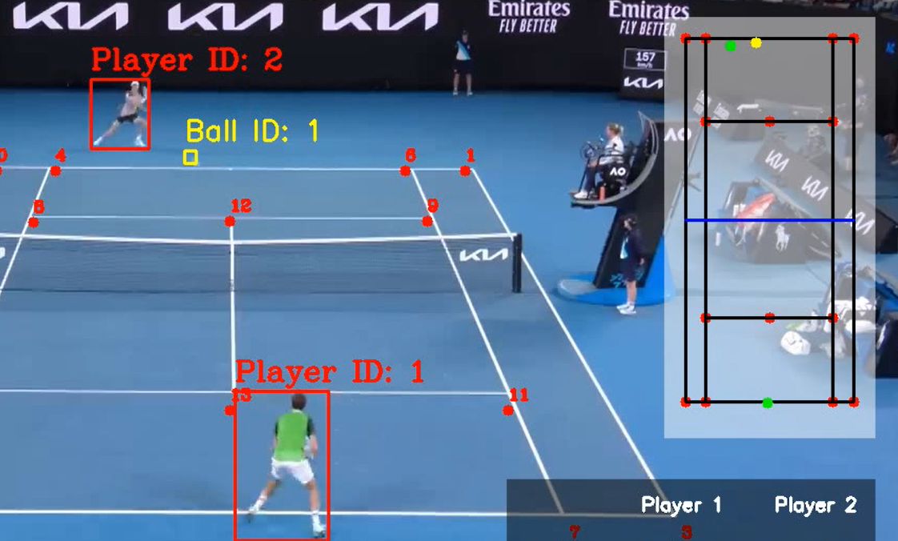Secondly, comparing the player and ball points on the mini court to the actual match footage for input videos.

What becomes apparent is that the player representation is both stable and accurate. The ball on the other hand is jittery and often experiences ‘teleportation’ across the court. This is understandable as its position is often interpolated which can result in erroneous positions such as the above where the ball is in front of Player 2 but it is indicated as being behind on the diagram.

## Stage 7: Video Player

I used the default python GUI library Tkinter as I believed that it would be the most basic and maintain simplicity. However, there was no built-in video player so I imported the tkVideoPlayer library.

import datetime

import tkinter as tk

from tkinter import filedialog

from tkVideoPlayer import TkinterVideo

I created functions to update the progress bar on how far into the video the user has watched.

Def update_duration(event):

    duration = vid_player.video_info()[“duration”]

    end_time[“text”] = str(datetime.timedelta(seconds=duration))

    progress_slider[“to”] = duration

def update_scale(event):

    progress_value.set(vid_player.current_duration())

The load_video opens a file dialog which prompts the user to select a video file to import into the application for review. The video player’s configurations are reset such that it will begin from the start.

Def load_video():

    file_path = filedialog.askopenfilename()

    if file_path:

        vid_player.load(file_path)

        progress_slider.config(to=0, from_=0)

        play_pause_btn[“text”] = “Play”

        progress_value.set(0)

def seek(value):

    vid_player.seek(int(value))

These are more of the user’s usability features: the ability to skip to a certain part of the video and the option to pause or play. The text on the buttons are changed to avoid confusion and

Def skip(value: int):

    vid_player.seek(int(progress_slider.get())+value)

    progress_value.set(progress_slider.get() + value)

def play_pause():

    if vid_player.is_paused():

        vid_player.play()

        play_pause_btn[“text”] = “Pause”

    else:

        vid_player.pause()

        play_pause_btn[“text”] = “Play”

def video_ended(event):

    progress_slider.set(progress_slider[“to”])

    play_pause_btn[“text”] = “Play”

    progress_slider.set(0)

Here, I instantiated the UI objects and linked them to their appropriate functions. Furthermore, I declared the location and scaling of each component.

root = tk.Tk()

root.title("Tkinter media")

load_btn = tk.Button(root, text="Load", command=load_video)

load_btn.pack()

vid_player = TkinterVideo(scaled=True, master=root)

vid_player.pack(expand=True, fill="both")

play_pause_btn = tk.Button(root, text="Play", command=play_pause)

play_pause_btn.pack()

skip_plus_5sec = tk.Button(root, text="Skip -5 sec", command=lambda: skip(-5))

skip_plus_5sec.pack(side="left")

start_time = tk.Label(root, text=str(datetime.timedelta(seconds=0)))

start_time.pack(side="left")

progress_value = tk.IntVar(root)

progress_slider = tk.Scale(root, variable=progress_value, from_=0, to=0, orient="horizontal", command=seek)

progress_slider.pack(side="left", fill="x", expand=True)

end_time = tk.Label(root, text=str(datetime.timedelta(seconds=0)))

end_time.pack(side="left")

vid_player.bind("<<Duration>>", update_duration)

vid_player.bind("<<SecondChanged>>", update_scale)

vid_player.bind("<<Ended>>", video_ended )

skip_plus_5sec = tk.Button(root, text="Skip +5 sec", command=lambda: skip(5))

skip_plus_5sec.pack(side="left")

root.mainloop()

The resulting interface meets all the success criteria’s usability features:

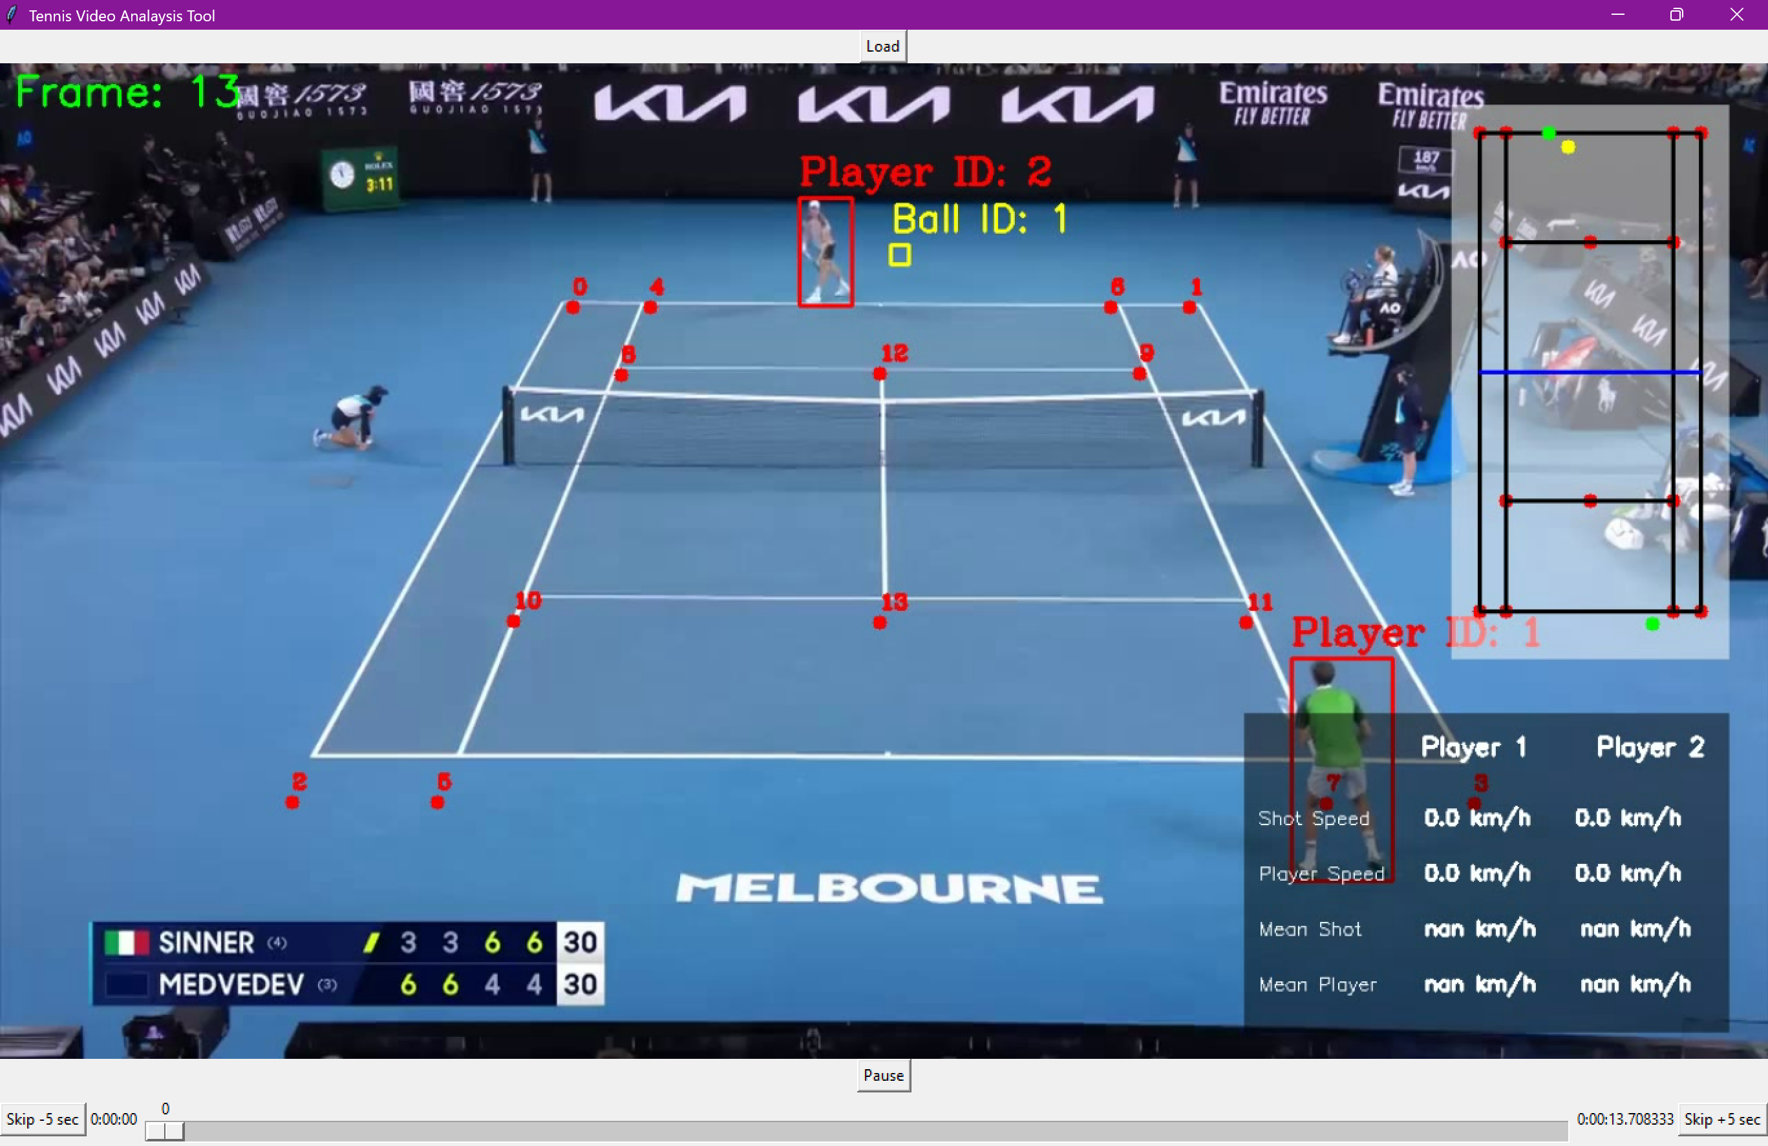

However, after thorough testing and research, I realised that this library is only compatible with Python versions <=3.10. My project virtual environment is based in 3.12 and to maintain consistency I wanted to find an alternative solution which would allow me to work under a singular virtual environment.

### Remedial Action – Kivy

As an alternative, I have swapped to the Kivy framework which is a cross-platform python GUI library that supports the latest version.

**Justification:** There is a large active community so there is an abundance of documentation for help in development

from kivy.app import App

from kivy.uix.boxlayout import BoxLayout

from kivy.uix.video import Video

from kivy.uix.button import Button

from kivy.uix.slider import Slider

from kivy.uix.filechooser import FileChooserIconView

from kivy.uix.popup import Popup

from kivy.clock import Clock

from kivy.uix.label import Label

import os

Importing the required components for the UI from the Kivy library and then defining the class of the VideoPlayerApp.

class VideoPlayerApp(App):

    def build(self):

        # Main layout

        layout = BoxLayout(orientation='vertical')

        # Video player widget

        self.video = Video(source="output_video.mp4", state='stop', options={'eos': 'loop'})

        layout.add_widget(self.video)

This code implements the video player and extracts by default the video in the location of “output_video.mp4”. It has formatted the UI such that the video player sits above the horizontal row of control buttons as shown in the design section.

**Justification:** This will be the format that most are familiar with. It is what popular streaming services such as Youtube use.

        # Controls layout (horizontal)

        controls = BoxLayout(size_hint_y=0.2)

        # Play button

        play_button = Button(text="Play", on_press=self.play_video)

        controls.add_widget(play_button)

        # Pause button

        pause_button = Button(text="Pause", on_press=self.pause_video)

        controls.add_widget(pause_button)

        # Stop button

        stop_button = Button(text="Stop", on_press=self.stop_video)

        controls.add_widget(stop_button)

        # File select button

        file_button = Button(text="Select File", on_press=self.open_filechooser)

        controls.add_widget(file_button)

The buttons are linked to their methods within the class and added to the controls layout container.

**Justification:** The on_press event links to the class methods.

        # Seek slider

        self.slider = Slider(min=0, max=100, value=0)

        self.slider.bind(on_touch_up=self.seek_video)

        controls.add_widget(self.slider)

        layout.add_widget(controls)

        # Update slider position periodically

        Clock.schedule_interval(self.update_slider, 0.5)

        return layout

    def play_video(self, instance):

        # Play the video

        if self.video.state != 'play':

            self.video.state = 'play'

    def pause_video(self, instance):

        # Pause the video

        if self.video.state == 'play':

            self.video.state = 'pause'

    def stop_video(self, instance):

        # Stop the video and reset to the beginning

        self.video.state = 'stop'

        self.video.seek(0)

        self.slider.value = 0

    def update_slider(self, dt):

        # Update the slider based on video progress

        if self.video.duration and self.video.state == 'play':

            self.slider.max = self.video.duration

            self.slider.value = self.video.position

    def seek_video(self, instance, touch):

        # Seek the video when the slider is moved

        if instance.collide_point(*touch.pos):

            self.video.seek(instance.value)

The slider will call back every 0.5 seconds to change the slider value if it has been moved. The value of the slider is calculated using the percentage of the length of the slider that is has been dragged.

**Justification:** The progress of the media file is shown with the percentage and the slider is a better representation of the video than buttons.

    def open_filechooser(self, instance):

        # Open file chooser dialog

        content = FileChooserIconView()

        content.bind(on_selection=lambda widget, selection: self.selected(selection))

        self.popup = Popup(title="Select a Video File", content=content, size_hint=(0.9, 0.9))

        self.popup.open()

    def selected(self, selection):

        # Callback for file selection

        if selection:

            video_file = selection[0]

            self.video.source = video_file

            self.video.state = 'stop'

            self.video.seek(0)

            self.slider.value = 0

            self.popup.dismiss()

            print(f"Selected file: {video_file}")

if __name__ == "__main__":

    VideoPlayerApp().run()

The file chooser dialog provides the user a visual way to browse for their input.

**Justification:** The file dialog is a ‘Popup’ so only part of the main window is covered and is a non-intrusive window.

### Criteria Fulfilled

Video player to play back output labelled video

Video controls for the video player

### Review

Swapping from Tkinter to Kivy and implementing the success criteria requirements has been a smooth process. The main menu window is functioning as expected. Through the select file button, the input video can be chosen from the file dialog by navigating the system files. The play button starts running the video whereas the stop button completely stops the video. The pause button allows the video to be stopped at a set time. The slider on the right allows the user to select a position in the video to start from and live updates depending on where in the video the user is watching.

### Validation

Every time a new part of the interface was added, I ran the program and manually pressed each button to check whether it followed its function. Specifically, I implemented the play, pause and stop buttons first; then the slider; then the select file button. Using samples videos in different file locations I ensured the file selection function returned the correct file path by printing file_path . Moreover, I watched over whether the layout was aligned correctly.

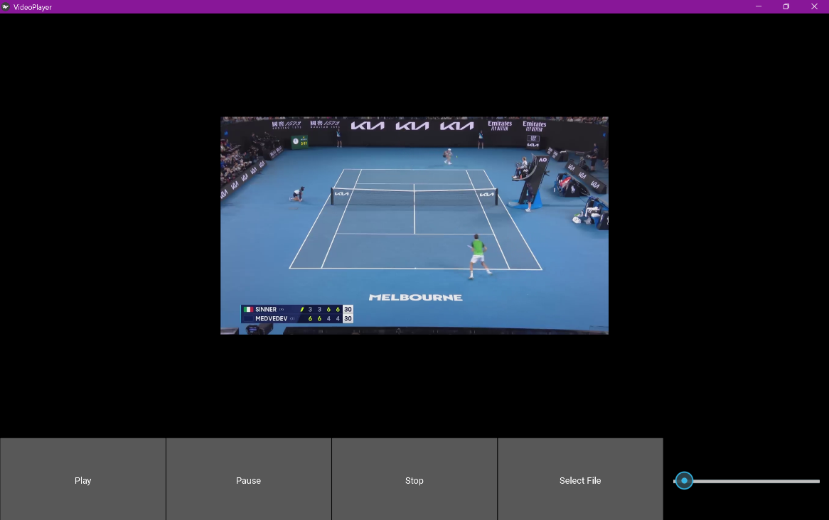

# Post-Development Testing

## Testing for Function and Robustness

Provided annotated evidence of post-development testing for function and robustness.

|  |  |  |  |
| --- | --- | --- | --- |
| **Test** | **Input** | **Expected Outcome** | **Actual Outcome** |
| Window | Fullscreen button | The user interface expands to maximum size | As expected    Application becomes full screen |
|  | Exit button | The application closes | As expected |
| Video Slider | Mouse click on the far left of the slider | Video play from the beginning | As expected |
|  | Mouse click in the middle of the slider | Video plays from the position selected as a ratio of the video | Not functioning correctly. It goes to the end of the video immediately |
|  | Mouse click on the far right of the slider | Video play from the end and stops | As expected |
|  | Drag the slider from start to end | Video plays from the end and stops | As expected |
|  | Drag the slider from arbitrary point in the middle to arbitrary point | Video plays initial point and moves to new arbitrary point | Not functioning correctly. It goes to the end of the video immediately |
| Play Button | Press play button | The video starts playing from the beginning | As expected |
|  | Pressing play button multiple times | The video continues playing and is not affected after the first press | As expected |
| Pause Button | Press pause button | The video stops playing and pauses at a select frame | As expected |
|  | Press pause and then play button | The video stops playing and then starts playing again from where it was paused | As expected |
| Stop Button | Press stop button | The video stops and pauses on the first frame of the video | As expected |
|  | Press play button and then stop button | Video plays and then the video | As expected |
|  | Press pause button and then stop button | Video pauses at the frame where it was playing last and then goes to the start of the video and pauses | As expected |
| Select File Button | Press select file button | Opens a file dialog | As expected |
| File Dialog | Press folder | Enters the directory and displays all of the subdirectories | As expected  Evidence of entering sub-directory |
|  | Select video file | Passes the video file path to the main video processing function and starts playing the output video when it has been produced | As expected |
|  | Select non-compatible file of wrong format | The file dialog prompts the user to re-select and alerts an error message that an erroneous file type has been chosen | Not functioning correctly. The user interface crashes when a non-video file is passed. |
|  | Select video of large file size | The video is still processed and the result is displayed | As expected. However, takes a significant larger amount of time. |

|  |  |
| --- | --- |
| **Video** | **Outcome** |
| A person playing tennis on a blue court  AI-generated content may be incorrect.  ATP Video (Standard Top Down Competition Video) | Model always works and is able to detect objects with high degree of accuracy |
| A tennis court with a net with Ice hockey rink in the background  AI-generated content may be incorrect.  Video where a player is outside of the camera frame | Code runs into error due to having no code to fall back on when bounding box outside frame |
| A couple of people playing tennis  AI-generated content may be incorrect.  Clay video with people walking past | Detects the players correctly but the keypoints have significant offset |
| A person swinging a tennis racket on a tennis court  AI-generated content may be incorrect.  Low angle grass court | Key points are severely affected and results can be considered as unsuccessful |

## Testing for Usability

Provided annotated evidence for usability testing.

Following the final prototype’s development, I started with a whole project visual inspection. Immediately, a noticeable issue is that the video player is very small on the window.

To fix this I made the controls at the bottom take up a smaller size.

controls = BoxLayout(size_hint_y=0.2)

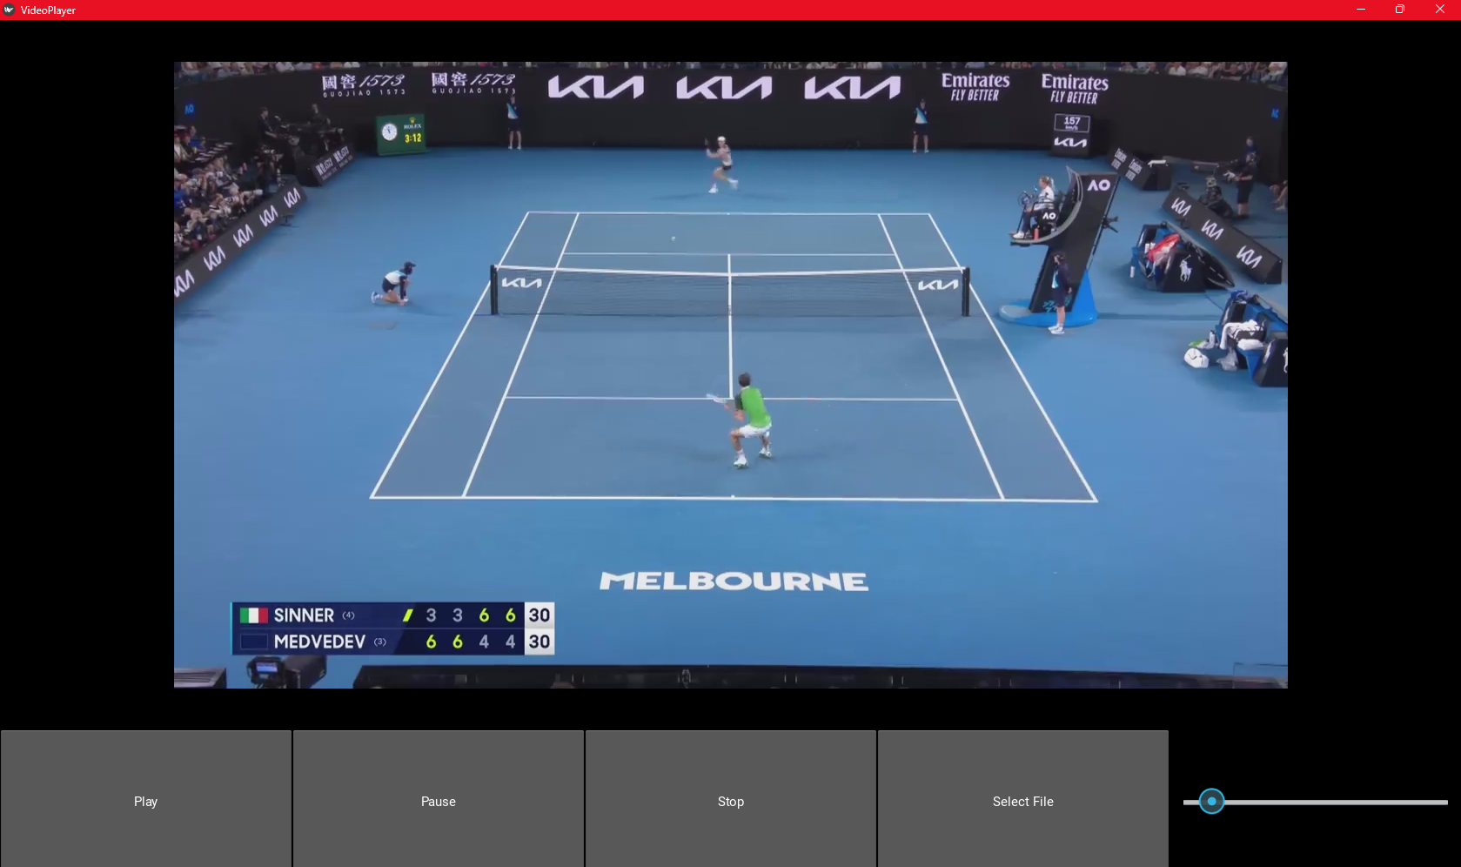

|  |  |  |
| --- | --- | --- |
| **Check** | **Actual Outcome** | **Description** |
| Icons and UI elements are intuitive | As expected | The play, pause, stop, select file and slider icons were easily recognisable. |
| Elements are clearly labelled and easy to understand | Issue found | The slider’s purpose is not clearly recognisable. |
| Video player controls are accessible | As expected | Buttons and sliders are large enough for easy interaction. |
| Contrast and text readability are sufficient | As expected | Text is clear and readable against the background. |
| Keyboard shortcuts are available and functional | Issue Found | No shortcuts for play, pause, or full screen mode were found. |
| Load time and responsiveness are acceptable | As expected | The app loads quickly with minimal lag. |
| All elements are named accurately | To an extent | The buttons are named but the slider does not have any descriptive text. |

## Hardware

Since Kivy is a cross-platform library, I ran my code environment on other hardware devices and was able to confirm that it can be run beyond my own local device. This demonstrates that the application is robust and not hardware dependent.

## Stakeholder Feedback

I interviewed a tennis player who plays for the 1st team to evaluate the usability features. This will be my target audience as he is passionate about improving his game and would benefit from numerical data. The transcript of this interview has been provided along with my reflections on the suggestions.

### Interview

**Question 1:** Is the layout of the user interface intuitive?

**Answer:** Well, I guess so. There aren’t a lot of things to press and the icons are pretty approachable. However, I wasn’t sure what the slider did until I tried it out. I also did not know

**Question 2:** Any comments on the font used?

When the window is full screen the text on the buttons are quite small. When I minimise the window it’s pretty large. Overall, no major complaints but maybe resize the text when you change the window size to scale with the buttons?

**Question 3:** Does the application allow you to view the processed video?

Yes, the video plays after my selected video has been processed. However, I wasn’t really sure what was happening in the really long time during which it was processing it. Maybe some sort of loading screen would be useful.

**Question 4:** Are you able to control how you watch the video using the elements?

Yeah. I don’t particularly get the point of the stop button when you have the other buttons which allow you to do the same thing. Pretty basic setup but it does the job.

**Question 5:** Were you able to understand your game in a more analytical perspective?

Yes. The court diagram is pretty cool. Seeing the numbers of the shot speeds is fun. Could you implement a top serve speed or fastest shot hit in the rally?

**Question 6:** Any further comments?

Some sort of instructions would be useful. As a user, I didn’t really know what the app was doing and how to navigate it. But with the knowledge that I have to input my video, it is pretty intuitive overall. I do have to say I would not realistically use this because it is so slow.

### Reflection

There were a few key suggestions made by the stakeholder:

* Add instructions page which explain how to navigate the app and its purpose
* Remove the stop button
* Dynamically growing text
* Add a loading screen during processing
* Top serve speed and shot statistic
* Increase the speed of processing

Unfortunately, due to time constrains, I can not include these features in the prototype but they will be considered in future development. As a result, the usability features were partially successful since base features were included but there is a lot of room for improvement.

# Evaluation

Used the test evidence to cross-reference with the success criteria to evaluate the solution. Explain how the evidence shows that the criteria has been fully, partially or not met in each case.

Provided comments on how any partially or unmet criteria could be addressed in further development.

Provided evidence of the usability features justifying their success, partial success or failure as effective usability features.

## Success Criteria

### Simple and intuitive interface design

|  |  |  |
| --- | --- | --- |
| **Criteria** | **Justification** | **How to Evidence** |
| Simple and intuitive interface design | Maintains focus on the key backend features. | Screenshot of the main window |

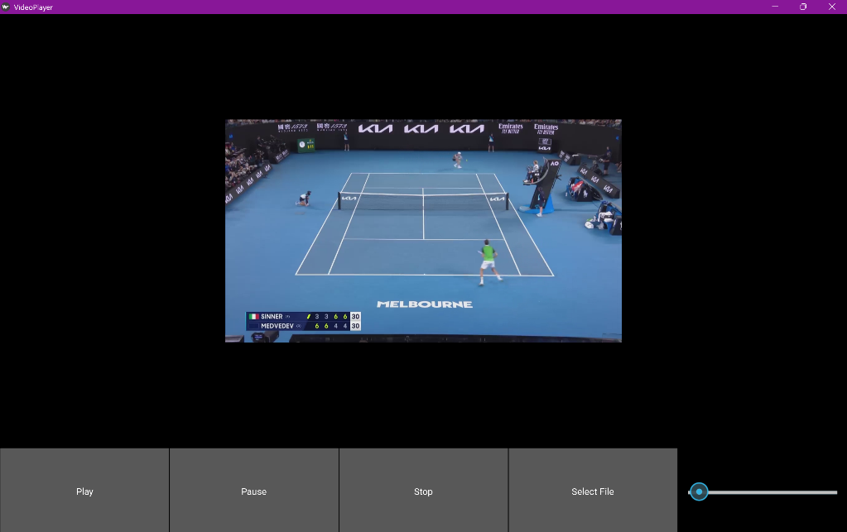

Overall, this criteria has been met quite well. There is only one main window so the user only needs to understand a single user interface; the user interface has very few components. The buttons are large and simply labelled for but text can be quite small depending on the size of the window.

### Make the application and processing of video fast

|  |  |  |
| --- | --- | --- |
| **Criteria** | **Justification** | **How to Evidence** |
| Make the application and processing of video fast | To reduce wait time for the user and enhance experience | Time the time taken to process the video |

I can measure the time taken for execution with the time library:

import time

start = time.time()

print("Finished Processing")

end = time.time()

print("Time to process: ", end - start)

With this, I can numerically attribute the performance of the application. My acceptable execution time threshold was < 1 second prior to testing.

Without stubs, the program needs to apply preprocessing, inference and postprocessing on each frame individually. 

Each frame taking approximately 1300ms, for a 1 minute video, this could take $1.3×60×60=4680s=78 minutes$ in the worst case scenario. This is considerably slow and when tested without using stubs, it took 923 seconds.

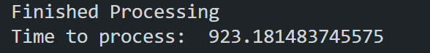

Whereas, with stubs the processing took 22 seconds which is about a 4160% improvement.

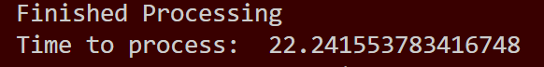

In conclusion, the execution time is too long to be acceptable under the success criteria but it is successful to an extent due to the considerable improvement.

#### Further Development

The structure of the solution I have developed relies on a frame by frame inference method. Therefore, it is severely limited in its time complexity by the number of frames.

### Outputs video with labelled objects & Train model to identify the key points of the tennis court & Train object detection models that can identify the position of the tennis balls & Train object detection models that can identify the position of the players

|  |  |  |
| --- | --- | --- |
| **Criteria** | **Justification** | **How to Evidence** |
| Outputs video with labelled objects | Increases the visualisation to help users to identify patterns | Screenshot of video that has labelled objects |
| Object detection model that can identify the position of the tennis balls | This allows for extraction of the ball speeds from any video frame | Utilise test data and visually check whether bounding box correctly outlines balls |
| Object detection model that can identify the position of the players | This allows for extraction of the player speeds from any video frame | Utilise test data and visually check whether bounding box correctly outlines players |
| Train model to identify the key points of the tennis court | Through the key points, I can subsequently align the coordinates of objects according to the angle of the camera | Comparison of model labelled key points and actual key points |

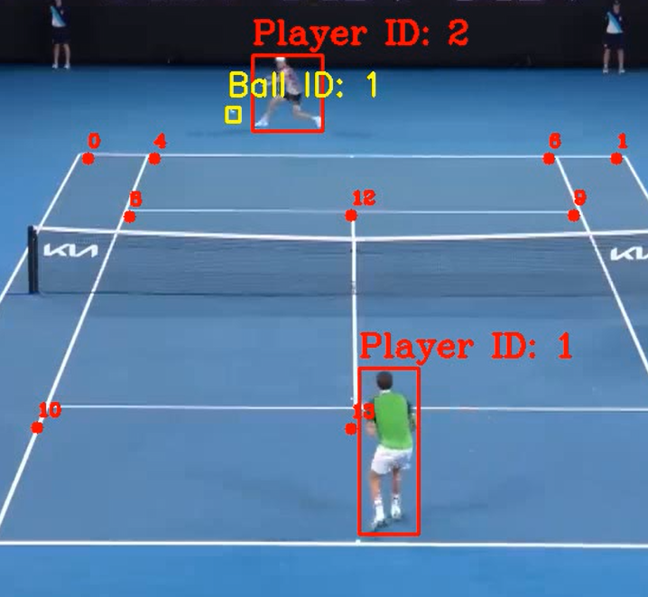On the whole, the detection models have partially met the success criteria. The pipeline works amazingly with the type of data it was trained with: professional matches. This, is not what result we wanted. As seen in the testing, amateur matches faced mixed results. The main downfall was the court keypoints detection where uncertainties built up.

The success criteria of output with labelled objects is only partially met since in edge cases the code crashes.

Looking at the YOLO models, the ball model works adequately for the quality of video and the interpolation helps out substantially. Conversely, the player model undoubtedly fulfilled the success criteria as it does not face the same speed issue as the ball. It is consistent throughout the test data and the correct players are identified.

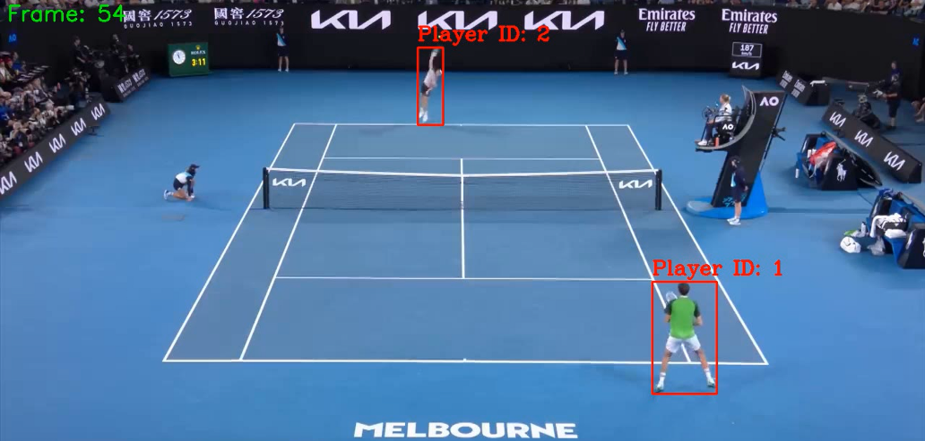

### Derive the speed of players and balls & Display of performance data

|  |  |  |
| --- | --- | --- |
| **Criteria** | **Justification** | **How to Evidence** |
| Derive the speed of players and balls | The key output for the whole project that the end user wants from their selected video | Screenshot of numbers at each frame |
| Display of performance data | Clear representation of data such that the user can understand the output of the program | Screenshot of numerical data on user interface |

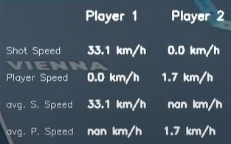Due to time constraints, I was unable to find datasets of matches and their stroke speeds so I do not have a direct comparison. However, I can assert that the average speeds were within the boundaries of typical tennis speeds. Thus, the success criteria has been met. Furthermore, it updates correctly in real time and meets the second success criteria.

#### Future Development

Finding official data and calculating the absolute and percentage difference would demonstrate the accuracy. Perhaps as mentioned by the stakeholder, I could manipulate the speed statistics to give insight into other statistical data such as fastest shot speed.

### Generate heat map diagram of shots

|  |  |  |
| --- | --- | --- |
| **Criteria** | **Justification** | **How to Evidence** |
| Generate heat map diagram of shots | This is a more visual representation of shot patterns and condenses shot data | Screenshot of heat diagram on user  interface |

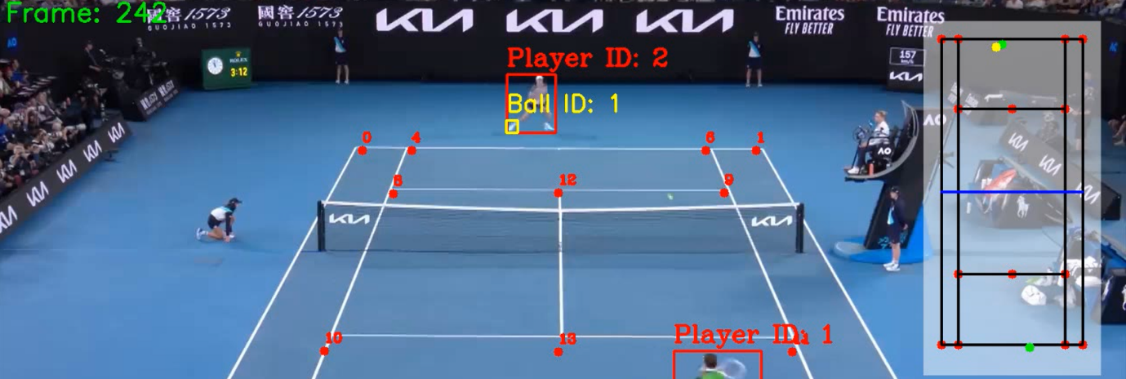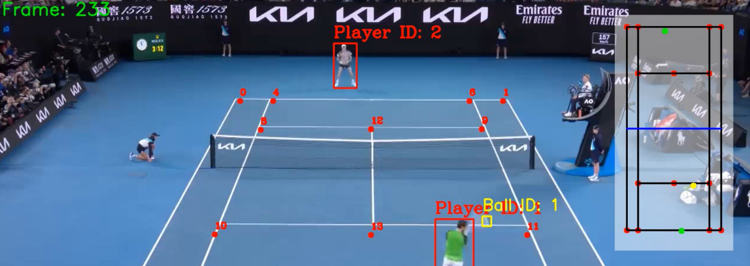

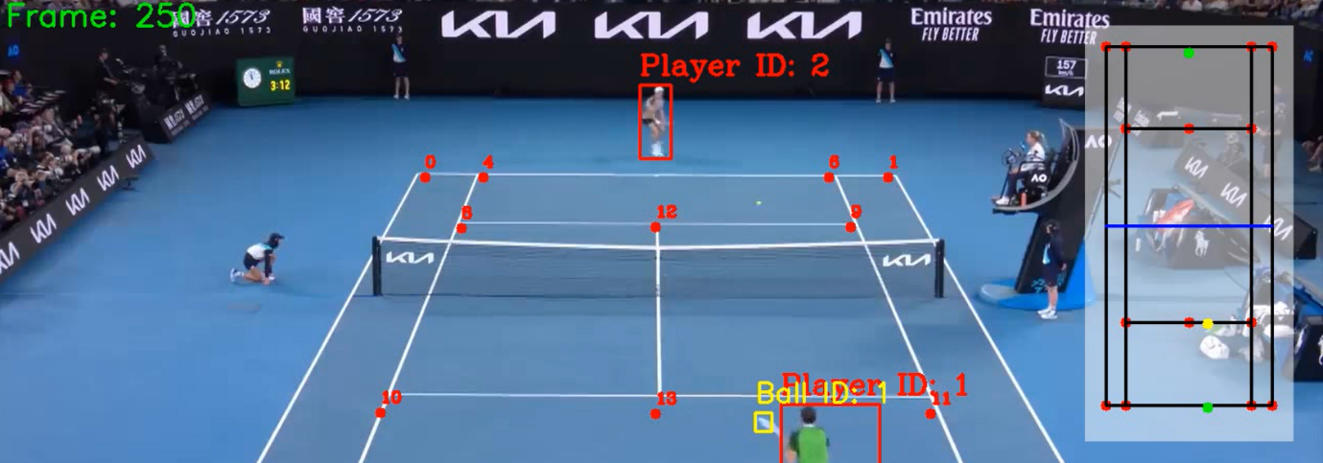

The player representation is highly accurate but the ball experiences tearing as shown in the screenshots above. However, this is a result of the coordinates calculations rather than the mini court conversion. The conversion between actual ratios to pixel ratios is clearly accurate. The mini court met the success criteria.

### File Selection Interface

|  |  |  |
| --- | --- | --- |
| **Criteria** | **Justification** | **How to Evidence** |
| File Selection Interface | To facilitate a direct method of selecting a file without needing to search for file path and hard code into application. This allows the user to input their own footage or games which they wish to be analysed rather than having prerequisite videos | Screenshot of opened file selection and selection of file |

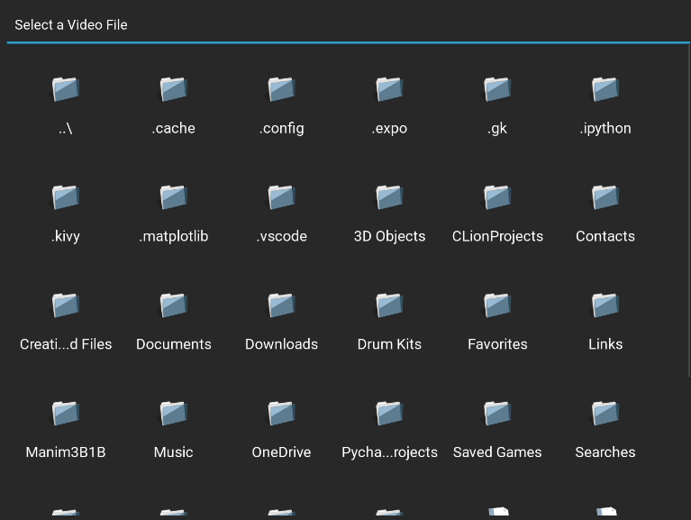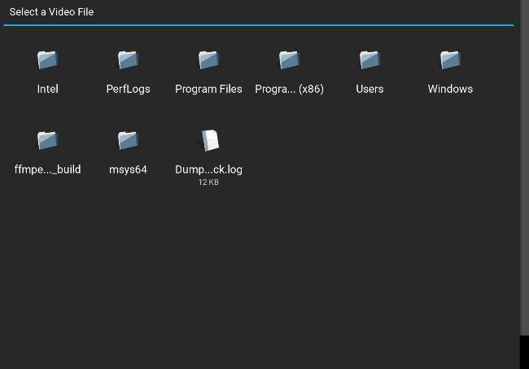

The file explorer system is partially met as the user can navigate files. Both entering a sub-directory and returning to a parent directory. Selecting an input video is also successful.

#### Future Development

However, further validation is required to check whether the selected file is of the right format in future development. Different test cases would need to be checked for and the user needs to be prompted again.

### Video player to play back output labelled video

|  |  |  |
| --- | --- | --- |
| **Criteria** | **Justification** | **How to Evidence** |
| Video player to play back output labelled video | Allows the user to watch the labelled video inside the application without needing to search in files | Test whether able to watch entire videos |

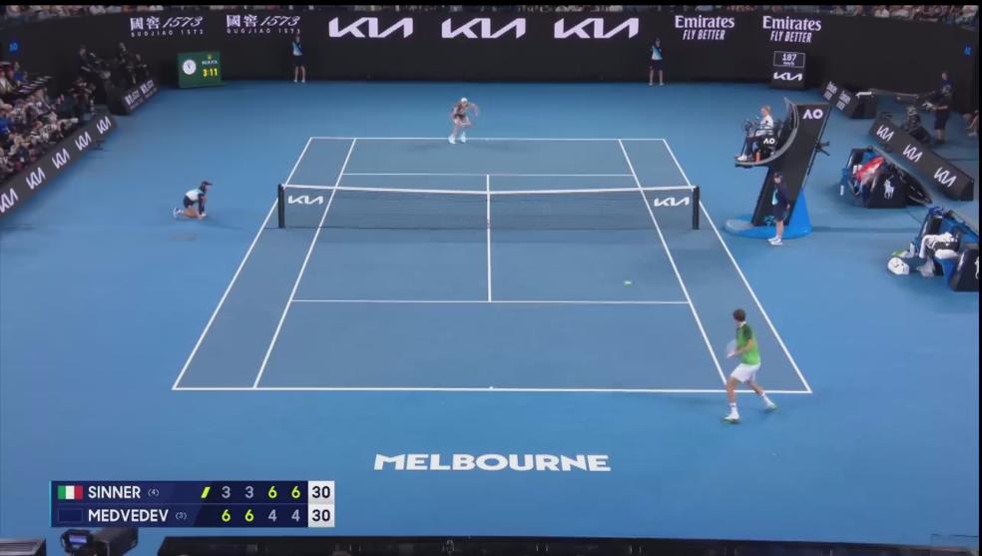

This was achieved perfectly and is demonstrated by the stakeholder testing.

### Video controls for the video player

|  |  |  |
| --- | --- | --- |
| **Criteria** | **Justification** | **How to Evidence** |
| Video controls for the video player | Access to key moments in timeline and navigate frame by frame for analysis | Test all buttons and features of video controls |

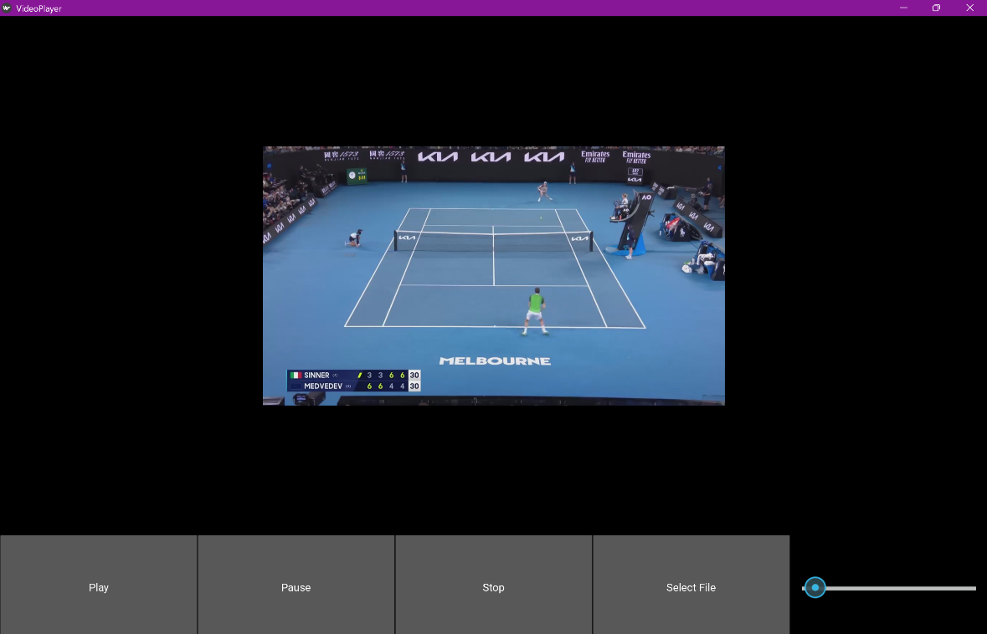

Making reference to the testing, the play, pause and stop button have achieved the success criteria. The buttons mediate control over video observation. The slider cannot adjust the video position and subsequently does not achieve the success criteria.

## Issues with Usability Features

Provided comments on how any issues with partially or unmet usability features could be addressed in further development.

|  |  |  |
| --- | --- | --- |
| **Criteria** | **Justification** | **How to Evidence** |
| Video controls for the video player | Access to key moments in timeline and navigate frame by frame for analysis | Test all buttons and features of video controls |

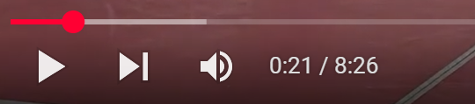The user interface is not well laid out in an aesthetic manner and could be improved through a redesign of the ratios of components. One change to address this would be to move the slider underneath the video and use an icon for the play button instead of labelled buttons. This would emulate the common practice of video players which most people know how to navigate.

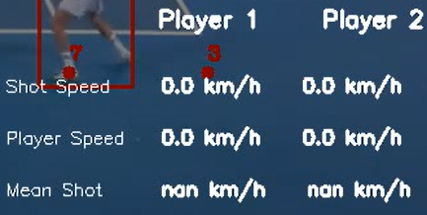A noticeable issue is that speeds are not immediately shown for the first few shots of the video. Initial N/A values can be displayed and can be debugged by setting breakpoints in the code.

From the stakeholder testing, the user interface does not clearly outline that the user must select a file to input into the machine learning model. A set of instructions would aid guidance on the purpose of the software.

## Limitations

Described how the program could be developed to deal with limitations of potential improvements/changes.

Currently, under the assumption that the camera angle remains the same throughout the video recording, the model only predicts the court’s key points at the starting frame. Thus, the model would not adjust accordingly if the camera were to change throughout its recording. Albeit, this can be fixed easily by detecting the key points every frame and updating the positions in exchange for slower processing.

Additionally, more detailed statistics can be chosen in further development beyond speed. For example, the area where the ball has landed in could be highlighted which can be implemented through set coordinate limits and checking whether the ball’s position lies within these bounds.

## Maintenance

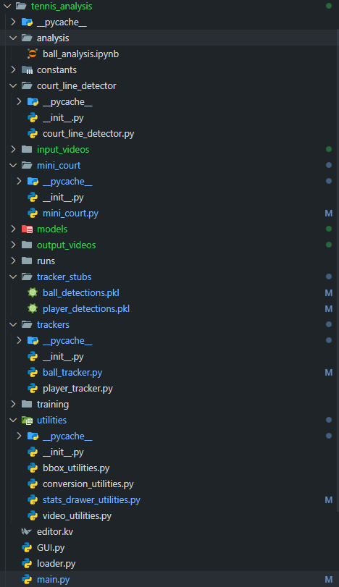Considered maintenance issues and limitations of the solution.

During development, I split the user interface code and functional code. Importantly, I have created utilities which can be reused globally throughout and the file structure provide an organised system for further implementation. Furthermore, the code is well formatted with comments such that the logic could be followed.

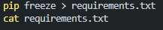Using pip I identified the project’s dependencies. There are a large number of libraries that are included in the virtual environment which need to be regularly updated in future maintenance. Developers would need to install the correct package versions to prevent inconsistencies.

The list of packages and their versions that were used:

certifi==2024.12.14

charset-normalizer==3.4.1

colorama==0.4.6

contourpy==1.3.1

cycler==0.12.1

docutils==0.21.2

ffpyplayer==4.5.2

filelock==3.16.1

filetype==1.2.0

fonttools==4.55.3

fsspec==2024.12.0

idna==3.10

Jinja2==3.1.5

Kivy==2.3.1

kivy-deps.angle==0.4.0

kivy-deps.glew==0.3.1

Kivy-Garden==0.1.5

kivy_deps.sdl2==0.8.0

kiwisolver==1.4.8

lap==0.5.12

MarkupSafe==3.0.2

matplotlib==3.10.0

mpmath==1.3.0

networkx==3.4.2

numpy==2.2.1

olefile==0.47

opencv-python==4.10.0.84

packaging==24.2

pandas==2.2.3

pillow==11.1.0

psutil==6.1.1

py-cpuinfo==9.0.0

Pygments==2.19.1

pyparsing==3.2.1

pypiwin32==223

python-dateutil==2.9.0.post0

pytz==2024.2

pywin32==308

PyYAML==6.0.2

requests==2.32.3

scipy==1.15.0

seaborn==0.13.2

setuptools==75.8.0

six==1.17.0

sympy==1.13.1

tkvideoplayer==2.8

torch==2.5.1

torchvision==0.20.1

tqdm==4.67.1

typing_extensions==4.12.2

tzdata==2024.2

ultralytics==8.3.58

ultralytics-thop==2.0.13

urllib3==2.3.0

wheel==0.45.1

During maintenance, there may a need to switch libraries or update code when certain features are deprecated as shown below.



Consideration of these factors will keep the project adaptable to future updates.

There is a well-developed line of reasoning which is clear and logically structured. The information presented is relevant and substantiated.

# Full Code

## Main.py

from utilities import (

    read_video,

    save_video,

    measure_distance,

    draw_player_stats,

    convert_pixel_distance_to_meters

)

from trackers import PlayerTracker, BallTracker

from court_line_detector import CourtLineDetector

from mini_court import MiniCourt

import constants

from copy import deepcopy

import cv2

import pandas as pd

import os

import time

start = time.time()

def main():

    input_video_path = "input_videos/clay.mp4"

    # Read the video frames

    video_frames = read_video(input_video_path)

    # print(video_frames)

    # Initialise the player tracker and ball tracker

    player_tracker = PlayerTracker(model_path="C:\\Users\\yuyao\\OneDrive\\Documents\\CS_Project\\models\\yolov8x.pt")

    ball_tracker = BallTracker(model_path="C:\\Users\\yuyao\\OneDrive\\Documents\\CS_Project\\models\\yolov5_last.pt")

    player_detections = player_tracker.detect_frames(

        video_frames,

        read_from_stub=True,

        # stub_path="tennis_analysis/tracker_stubs/player_detections.pkl"

        stub_path="C:\\Users\\yuyao\\OneDrive\\Documents\\CS_Project\\tennis_analysis\\tracker_stubs\\player_detections.pkl"

    )

    ball_detections = ball_tracker.detect_frames(

        video_frames,

        read_from_stub=True,

        # stub_path="tennis_analysis/tracker_stubs/ball_detections.pkl"

        stub_path="C:\\Users\\yuyao\\OneDrive\\Documents\\CS_Project\\tennis_analysis\\tracker_stubs\\ball_detections.pkl"

    )

    # court_model_path = "models/court_points_model.pth"

    court_model_path = "C:\\Users\\yuyao\\OneDrive\\Documents\\CS_Project\\models\\court_points_model.pth"

    court_line_detector = CourtLineDetector(court_model_path)

    court_keypoints = court_line_detector.predict(video_frames[0])

    player_detections = player_tracker.filter_players(court_keypoints, player_detections)

    mini_court = MiniCourt(video_frames[0])

    ball_detections = ball_tracker.interpolate_ball_positions(ball_detections)

    ball_shot_frames = ball_tracker.get_ball_shot_frames(ball_detections)

    player_mini_court_positions, ball_mini_court_positions = mini_court.convert_bounding_boxes_to_mini_court_coordinates(

        player_detections,

        ball_detections,

        court_keypoints

    )

    player_stats_data = [{

        'frame_num': 0,

        'player_1_number_of_shots': 0,

        'player_1_total_shot_speed': 0,

        'player_1_last_shot_speed': 0,

        'player_1_total_player_speed': 0,

        'player_1_last_player_speed': 0,

        'player_2_number_of_shots': 0,

        'player_2_total_shot_speed': 0,

        'player_2_last_shot_speed': 0,

        'player_2_total_player_speed': 0,

        'player_2_last_player_speed': 0,

    }]

    for ball_shot_ind in range(len(ball_shot_frames) - 1):

        start_frame = ball_shot_frames[ball_shot_ind]

        end_frame = ball_shot_frames[ball_shot_ind + 1]

        ball_shot_time_in_seconds = (end_frame - start_frame) / 24  # 24fps

        # Get distance covered by the ball

        distance_covered_by_ball_pixels = measure_distance(

            ball_mini_court_positions[start_frame][1],

            ball_mini_court_positions[end_frame][1]

        )

        distance_covered_by_ball_meters = convert_pixel_distance_to_meters(

            distance_covered_by_ball_pixels,

            constants.DOUBLE_LINE_WIDTH,

            mini_court.get_width_of_mini_court()

        )

        # Speed of the ball shot in km/h

        speed_of_ball_shot = distance_covered_by_ball_meters / ball_shot_time_in_seconds * 3.6

        # Player who shot the ball

        player_positions = player_mini_court_positions[start_frame]

        player_shot_ball = min(

            player_positions.keys(),

            key=lambda player_id: measure_distance(

                player_positions[player_id],

                ball_mini_court_positions[start_frame][1]

            )

        )

        # Opponent player speed

        opponent_player_id = 1 if player_shot_ball == 2 else 2

        distance_covered_by_opponent_pixels = measure_distance(

            player_mini_court_positions[start_frame][opponent_player_id],

            player_mini_court_positions[end_frame][opponent_player_id]

        )

        distance_covered_by_opponent_meters = convert_pixel_distance_to_meters(

            distance_covered_by_opponent_pixels,

            constants.DOUBLE_LINE_WIDTH,

            mini_court.get_width_of_mini_court()

        )

        speed_of_opponent = distance_covered_by_opponent_meters / ball_shot_time_in_seconds * 3.6

        current_player_stats = deepcopy(player_stats_data[-1])

        current_player_stats['frame_num'] = start_frame

        current_player_stats[f'player_{player_shot_ball}_number_of_shots'] += 1

        current_player_stats[f'player_{player_shot_ball}_total_shot_speed'] += speed_of_ball_shot

        current_player_stats[f'player_{player_shot_ball}_last_shot_speed'] = speed_of_ball_shot

        current_player_stats[f'player_{opponent_player_id}_total_player_speed'] += speed_of_opponent

        current_player_stats[f'player_{opponent_player_id}_last_player_speed'] = speed_of_opponent

        player_stats_data.append(current_player_stats)

    player_stats_data_df = pd.DataFrame(player_stats_data)

    frames_df = pd.DataFrame({'frame_num': list(range(len(video_frames)))})

    player_stats_data_df = pd.merge(frames_df, player_stats_data_df, on='frame_num', how='left')

    player_stats_data_df = player_stats_data_df.ffill()

    player_stats_data_df['player_1_average_shot_speed'] = player_stats_data_df['player_1_total_shot_speed'] / player_stats_data_df['player_1_number_of_shots']

    player_stats_data_df['player_2_average_shot_speed'] = player_stats_data_df['player_2_total_shot_speed'] / player_stats_data_df['player_2_number_of_shots']

    player_stats_data_df['player_1_average_player_speed'] = player_stats_data_df['player_1_total_player_speed'] / player_stats_data_df['player_2_number_of_shots']

    player_stats_data_df['player_2_average_player_speed'] = player_stats_data_df['player_2_total_player_speed'] / player_stats_data_df['player_1_number_of_shots']

    # Draw bounding boxes around the players and balls

    output_video_frames = player_tracker.draw_bboxes(video_frames, player_detections)

    output_video_frames = ball_tracker.draw_bboxes(output_video_frames, ball_detections)

    # Draw the key points on the court

    output_video_frames = court_line_detector.draw_keypoints_on_video(output_video_frames, court_keypoints)

    # Draw the mini court

    output_video_frames = mini_court.draw_mini_court(output_video_frames)

    output_video_frames = mini_court.draw_points_on_mini_court(output_video_frames, player_mini_court_positions)

    output_video_frames = mini_court.draw_points_on_mini_court(output_video_frames, ball_mini_court_positions, color=(0, 255, 255))

    # Draw player statistics on the video

    output_video_frames = draw_player_stats(output_video_frames, player_stats_data_df)

    # Overlay frame numbers on the output video

    for i, frame in enumerate(output_video_frames):

        cv2.putText(frame, f"Frame: {i}", (10, 30), cv2.FONT_HERSHEY_SIMPLEX, 1, (0, 255, 0), 2)

    save_video(output_video_frames, "tennis_analysis/output_videos/output_video.avi")

    print("Finished Processing")

    loaded = True

    end = time.time()

    print("Time to process: ", end - start)

if __name__ == "__main__":

    main()

## GUI.py

from kivy.app import App

from kivy.uix.boxlayout import BoxLayout

from kivy.uix.video import Video

from kivy.uix.button import Button

from kivy.uix.slider import Slider

from kivy.uix.filechooser import FileChooserIconView

from kivy.uix.popup import Popup

from kivy.clock import Clock

from kivy.uix.label import Label

import os

class VideoPlayerApp(App):

    def build(self):

        # Main layout

        layout = BoxLayout(orientation='vertical')

        # Video player widget

        self.video = Video(source="long_clip.mp4", state='stop', options={'eos': 'loop'})

        layout.add_widget(self.video)

        # Controls layout (horizontal)

        controls = BoxLayout(size_hint_y=0.2)

        # Play button

        play_button = Button(text="Play", on_press=self.play_video)

        controls.add_widget(play_button)

        # Pause button

        pause_button = Button(text="Pause", on_press=self.pause_video)

        controls.add_widget(pause_button)

        # Stop button

        stop_button = Button(text="Stop", on_press=self.stop_video)

        controls.add_widget(stop_button)

        # File select button

        file_button = Button(text="Select File", on_press=self.open_filechooser)

        controls.add_widget(file_button)

        # Seek slider

        self.slider = Slider(min=0, max=100, value=0)

        self.slider.bind(on_touch_up=self.seek_video)

        controls.add_widget(self.slider)

        layout.add_widget(controls)

        # Update slider position periodically

        Clock.schedule_interval(self.update_slider, 0.5)

        return layout

    def play_video(self, instance):

        # Play the video

        if self.video.state != 'play':

            self.video.state = 'play'

    def pause_video(self, instance):

        # Pause the video

        if self.video.state == 'play':

            self.video.state = 'pause'

    def stop_video(self, instance):

        # Stop the video and reset to the beginning

        self.video.state = 'stop'

        self.video.seek(0)

        self.slider.value = 0

    def update_slider(self, dt):

        # Update the slider based on video progress

        if self.video.duration and self.video.state == 'play':

            self.slider.max = self.video.duration

            self.slider.value = self.video.position

    def seek_video(self, instance, touch):

        # Seek the video when the slider is moved

        if instance.collide_point(*touch.pos):

            self.video.seek(instance.value)

    def open_filechooser(self, instance):

        # Open file chooser dialog

        content = FileChooserIconView()

        content.bind(on_selection=lambda widget, selection: self.selected(selection))

        self.popup = Popup(title="Select a Video File", content=content, size_hint=(0.9, 0.9))

        self.popup.open()

    def selected(self, selection):

        # Callback for file selection

        if selection:

            video_file = selection[0]

            self.video.source = video_file

            self.video.state = 'stop'

            self.video.seek(0)

            self.slider.value = 0

            self.popup.dismiss()

            print(f"Selected file: {video_file}")

if __name__ == "__main__":

    VideoPlayerApp().run()

## Editor.kv

Root:

text_input: text_input

BoxLayout:

orientation: 'vertical'

BoxLayout:

size_hint_y: None

height: 30

Button:

text: 'Load'

on_release: root.show_load()

Button:

text: 'Save'

on_release: root.show_save()

BoxLayout:

TextInput:

id: text_input

text: ''

RstDocument:

text: text_input.text

show_errors: True

<LoadDialog>:

BoxLayout:

size: root.size

pos: root.pos

orientation: "vertical"

FileChooserListView:

id: filechooser

BoxLayout:

size_hint_y: None

height: 30

Button:

text: "Cancel"

on_release: root.cancel()

Button:

text: "Load"

on_release: root.load(filechooser.path, filechooser.selection)

<SaveDialog>:

text_input: text_input

BoxLayout:

size: root.size

pos: root.pos

orientation: "vertical"

FileChooserListView:

id: filechooser

on_selection: text_input.text = self.selection and self.selection[0] or ''

TextInput:

id: text_input

size_hint_y: None

height: 30

multiline: False

BoxLayout:

size_hint_y: None

height: 30

Button:

text: "Cancel"

on_release: root.cancel()

Button:

text: "Save"

on_release: root.save(filechooser.path, text_input.text)

## Ball_training.ipynb

# Imports

%pip install roboflow

%pip install ultralytics

# Dataset setup and initialization

from roboflow import Roboflow

rf = Roboflow(api_key="lKZviSUoeNftJdgxc5wi")

project = rf.workspace("viren-dhanwani").project("tennis-ball-detection")

version = project.version(6)

dataset = version.download("yolov5")

# Move Files

import shutil

shutil.move("tennis-ball-detection-6/train",

            "tennis-ball-detection-6/tennis-ball-detection-6/train"

            )

shutil.move("tennis-ball-detection-6/test",

            "tennis-ball-detection-6/tennis-ball-detection-6/test"

            )

shutil.move("tennis-ball-detection-6/valid",

            "tennis-ball-detection-6/tennis-ball-detection-6/valid"

            )

# Model

*!*yolo task=detect mode=train model=yolov5l6u.pt data={dataset.location}/data.yaml epochs=100 imgsz=640

## Court_points_training.ipynb

# Imports

import torch

from torch.utils.data import Dataset, DataLoader

from torchvision import models, transforms

import json

import cv2

import numpy as np

# If there's a GPU available we'll use it otherwise we'll use the CPU

device = torch.device("cuda" if torch.cuda.is_available() else "cpu")

# Dataset

# Retrieves zipped dataset from google drive

*!*wget *--*header="Host: drive.usercontent.google.com" *--*header="User-Agent: Mozilla/5.0 (Windows NT 10.0; Win64; x64) AppleWebKit/537.36 (KHTML, like Gecko) Chrome/121.0.0.0 Safari/537.36" *--*header="Accept: text/html,application/xhtml+xml,application/xml;q=0.9,image/avif,image/webp,image/apng,*/*;q=0.8,application/signed-exchange;v=b3;q=0.7" *--*header="Accept-Language: en-US,en;q=0.9,ar;q=0.8" *--*header="Cookie: HSID=Ag2OIHvsd2Wub4C7z; SSID=AWnBcQKwDHiTrZAU1; APISID=pltrFZgE9lJ0o1gq/AN9feEHYvs8oHd519; SAPISID=zgF45F21ZPWzYWZw/AgUMJ8b7QQXuWGn19; __Secure-1PAPISID=zgF45F21ZPWzYWZw/AgUMJ8b7QQXuWGn19; __Secure-3PAPISID=zgF45F21ZPWzYWZw/AgUMJ8b7QQXuWGn19; SID=g.a000fwgYx1PcnW-rFyFhg3x6mQHzCrwXz-KFhoOLogUl7YTWI-uttBbVDRolhF-hY16nwHXw0gACgYKAWISAQASFQHGX2MivNTw_E_toJuIRy6LMpKNOBoVAUF8yKpFSmvq7AMjvEWeNc50Zff40076; __Secure-1PSID=g.a000fwgYx1PcnW-rFyFhg3x6mQHzCrwXz-KFhoOLogUl7YTWI-utbSY2jBY1VXuw8gYl5hIO2QACgYKAXsSAQASFQHGX2MihVCJ1PwLozGqZgdSatM9QhoVAUF8yKpgrsTvI8i_UE-YHpoN7Gx-0076; __Secure-3PSID=g.a000fwgYx1PcnW-rFyFhg3x6mQHzCrwXz-KFhoOLogUl7YTWI-utwVfPl2imdPimZJ9tdDZGQAACgYKAUESAQASFQHGX2MiEJ49mV4jME2kttDAV5hwWBoVAUF8yKp80mIgju1lu-q4nI7VsFDM0076; NID=511=efI9IZpxtyJ7Dw1MAUXU8FlzS5jXGewY4Er8HliWc3A0RSWdgvNDyKY66ETjgRyTGWPbWODSmiSeYSBab5SPHVwqbJxd6ZeGW2f6BkHi61UKksXPH0CVJRM1hKpMjHPU5qw7tboM2Mi87NrosV8COB-GCLulLLbjOoSAEQewTe8NVZ5Owq8IkwvxFGfJkmUKEMkFWrw9yb5nTDl3wbZEsGFI92iEdNTSxSRovNCIPN2US-SCFdQ0m2BtvwdiWZbgnn7dSQ8yPA145Kk2BA-ATpJNJ6SJHEHLQY-9CPail9D5qgJgxR925EUg5RGCpEu9wS5xbA62KTa19wAvbAq7Dk3TWc-iX4p1s7ESFyDC7yMpFxiFPJjqkWwFi_ZfiK2TW2t0TQ60DFBxqOytQaLyHrkEvD-CQPVj6OCOP22cZY0Cu61HaAQgFO9pXH-kJUlywzVdbirJumN5gswyaQ49b3KdLcG0Jb7brOMTM24T2nGtQ10hJzsnTwX7dBk3ujqQrI_DGuURvPassPUrIZ0; AEC=Ae3NU9MOEGeKAZjP6INpOYbyMraWAWztmx5pJB_1ILu1furiTy1K37k15u0; __Secure-1PSIDTS=sidts-CjEBYfD7Z9twEKTWJ9gU7KG-rLbxJGNRQIoG3wH6JVu6yiCC2fsRrm7tN8L6d5WlILrnEAA; __Secure-3PSIDTS=sidts-CjEBYfD7Z9twEKTWJ9gU7KG-rLbxJGNRQIoG3wH6JVu6yiCC2fsRrm7tN8L6d5WlILrnEAA; 1P_JAR=2024-02-18-08; SIDCC=ABTWhQExCxkfmwCkG1RaEgz8U1ZkPeh3HmLMUdMt8S5cNSsLY5U5rAL6wlvq7dtjRw7zrtAbqsFI; __Secure-1PSIDCC=ABTWhQH0jLeRIS6Tu3LS8DXB5Q3gGDq9LTmlk60FKu795Bf0UbzsOcYWVAE96clq5aAL8i724Q0; __Secure-3PSIDCC=ABTWhQHIFcyv3nZYwp78WXEQal71jCE_ZsGT5lXs8VLr7XDIfFqHcLTIPz4HxzJb9ZnYQ5l2s9eU" *--*header="Connection: keep-alive" "https://drive.usercontent.google.com/download?id=1lhAaeQCmk2y440PmagA0KmIVBIysVMwu&export=download&authuser=0&confirm=t&uuid=3077628e-fc9b-4ef2-8cde-b291040afb30&at=APZUnTU9lSikCSe3NqbxV5MVad5T%3A1708243355040" -c -O 'tennis_court_det_dataset.zip'

*!*unzip tennis_court_det_dataset.zip

class PointsDataset(Dataset):

    def __init__(self, img_dir, data_file):

        self.img_dir = img_dir

        # Reads dictionary from json file

        with open(data_file, "r") as f:

            self.data = json.load(f)

# Transforms data into right size

        # Define a series of transformations to preprocess the images

        self.transform = transforms.Compose([

            # Convert the image from a NumPy array to a PIL image

            transforms.ToPILImage(),

            # Resize the image to 224x224 pixels

            transforms.Resize((224, 224)),

            # Convert the image to a PyTorch tensor

            transforms.ToTensor(),

            # Normalize the image using the mean and standard deviation of ImageNet

            transforms.Normalize(

            mean=[0.485, 0.456, 0.406],  # Mean for each channel (R, G, B)

            std=[0.229, 0.224, 0.225]    # Standard deviation for each channel (R, G, B)

            )

        ])

    def __len__(self):

        return len(self.data)

    def __getitem__(self, idx):

        # Given an index, returns the image and the points

        item = self.data[idx]

        img = cv2.imread(f"{self.img_dir}/{item['id']}.png")

        height, width = img.shape[:2]

        img = cv2.cvtColor(img, cv2.COLOR_BGR2RGB)

        img = self.transform(img)

        # Array becomes 1D

        points = np.array(item['kps']).flatten()

        points = points.astype(np.float32)

        # Scale points to 224x224

        points[::2] *= 224 / width

        points[1::2] *= 224 / height

        return img, points

# Splitting data into training and validation

training_dataset = PointsDataset("data/images", "data/data_train.json")

validation_dataset = PointsDataset("data/images", "data/data_val.json")

training_loader = DataLoader(training_dataset, batch_size=32, shuffle=True)

validation_loader = DataLoader(validation_dataset, batch_size=32, shuffle=True)

# Model

# Load pre-trained model

model = models.resnet50(pretrained=True)

# Fine-tune model by changing the last layer to output x and y coordinates for the 14 keypoints

model.fc = torch.nn.Linear(model.fc.in_features, 14 * 2)

# Move model to device

model = model.to(device)

# Define loss function and optimiser

criterion = torch.nn.MSELoss()

optimiser = torch.optim.Adam(model.parameters(), lr=0.001)

epochs = 20

for epoch in range(epochs):

    for i, (imgs, points) in enumerate(training_loader):

        imgs = imgs.to(device)

        points = points.to(device)

        # Zero gradients before each iteration

        optimiser.zero_grad()

        # Model outputs the predicted points

        outputs = model(imgs)

        # Calculate loss

        loss = criterion(outputs, points)

        # Backpropagation

        loss.backward()

        optimiser.step()

        if (i % 10) == 0:

            print(f"Epoch {epoch}, Iteration {i}, Loss: {loss.item()}")

# Save model

torch.save(model.state_dict(), "court_points_model.pth")

## Ball_tracker.py

from ultralytics import YOLO

import cv2

import pickle

import pandas as pd

class BallTracker:

    def __init__(self, model_path):

        # Initialise the YOLO model with the given model path

        self.model = YOLO(model_path)

    def interpolate_ball_positions(self, ball_positions):

        # Extract the ball positions from the dictionary

        ball_positions = [x.get(1, []) for x in ball_positions]

        # Convert the list of dictionaries to a pandas DataFrame

        df_ball_positions = pd.DataFrame(ball_positions, columns=['x1', 'y1', 'x2', 'y2'])

        # Interpolate the missing values in the DataFrame

        df_ball_positions = df_ball_positions.interpolate()

        # Fill the remaining missing values with the last valid value

        df_ball_positions = df_ball_positions.bfill()

        # Convert the DataFrame back to a list of dictionaries

        ball_positions = [{1: x} for x in df_ball_positions.to_numpy().tolist()]

        return ball_positions

    def get_ball_shot_frames(self, ball_positions):

        # Extract the ball positions from the dictionary

        ball_positions = [x.get(1, []) for x in ball_positions]

        # Convert the list into a pandas DataFrame

        df_ball_positions = pd.DataFrame(ball_positions, columns=['x1', 'y1', 'x2', 'y2'])

        # Initialize the 'ball_hit' column with 0

        df_ball_positions['ball_hit'] = 0

        # Calculate the midpoint of the y-coordinates of the bounding boxes

        df_ball_positions['mid_y'] = (df_ball_positions['y1'] + df_ball_positions['y2']) / 2

        # Calculate the rolling mean of the mid_y values with a window size of 5

        df_ball_positions['mid_y_rolling_mean'] = df_ball_positions['mid_y'].rolling(window=5, min_periods=1, center=False).mean()

        # Calculate the difference between consecutive rolling mean values

        df_ball_positions['delta_y'] = df_ball_positions['mid_y_rolling_mean'].diff()

        # Define the minimum number of frames for a hit detection

        minimum_change_frames_for_hit = 25

        # Iterate through the DataFrame to detect ball hits

        for i in range(1, len(df_ball_positions) - int(minimum_change_frames_for_hit * 1.2)):

            # Check for a negative to positive or positive to negative change in delta_y

            negative_position_change = df_ball_positions['delta_y'].iloc[i] > 0 and df_ball_positions['delta_y'].iloc[i + 1] < 0

            positive_position_change = df_ball_positions['delta_y'].iloc[i] < 0 and df_ball_positions['delta_y'].iloc[i + 1] > 0

            if negative_position_change or positive_position_change:

                change_count = 0

                # Check for consistent changes in the following frames

                for change_frame in range(i + 1, i + int(minimum_change_frames_for_hit * 1.2) + 1):

                    negative_position_change_following_frame = df_ball_positions['delta_y'].iloc[i] > 0 and df_ball_positions['delta_y'].iloc[change_frame] < 0

                    positive_position_change_following_frame = df_ball_positions['delta_y'].iloc[i] < 0 and df_ball_positions['delta_y'].iloc[change_frame] > 0

                    if negative_position_change and negative_position_change_following_frame:

                        change_count += 1

                    elif positive_position_change and positive_position_change_following_frame:

                        change_count += 1

                # Mark the frame as a ball hit if the change count exceeds the threshold

                if change_count > minimum_change_frames_for_hit - 1:

                    # df_ball_positions['ball_hit'].iloc[i] = 1

                    df_ball_positions.loc[i, 'ball_hit'] = 1

        # Get the frame numbers where ball hits are detected

        frame_nums_with_ball_hits = df_ball_positions[df_ball_positions['ball_hit'] == 1].index.tolist()

        return frame_nums_with_ball_hits

    def detect_frames(self, frames, read_from_stub=False, stub_path=None):

        ball_detections = []

        # If read_from_stub is True, load ball detections from the stub file

        if read_from_stub and stub_path is not None:

            with open(stub_path, 'rb') as f:

                ball_detections = pickle.load(f)

            return ball_detections

        # Detect ball positions in each frame

        for frame in frames:

            player_dict = self.detect_frame(frame)

            ball_detections.append(player_dict)

        # Save ball detections to the stub file if stub_path is provided

        if stub_path is not None:

            with open(stub_path, 'wb') as f:

                pickle.dump(ball_detections, f)

        return ball_detections

    def detect_frame(self, frame):

        # Use the YOLO model to predict ball positions in the frame

        results = self.model.predict(frame, conf=0.15)[0]

        ball_dict = {}

        # Extract the bounding box coordinates for each detected ball

        for box in results.boxes:

            result = box.xyxy.tolist()[0]

            ball_dict[1] = result

        return ball_dict

    def draw_bboxes(self, video_frames, player_detections):

        output_video_frames = []

        # Draw bounding boxes on each frame

        for frame, ball_dict in zip(video_frames, player_detections):

            for track_id, bbox in ball_dict.items():

                x1, y1, x2, y2 = bbox

                # Draw the ball ID and bounding box on the frame

                cv2.putText(frame, f"Ball ID: {track_id}", (int(bbox[0]), int(bbox[1] - 10)), cv2.FONT_HERSHEY_SIMPLEX, 0.9, (0, 255, 255), 2)

                cv2.rectangle(frame, (int(x1), int(y1)), (int(x2), int(y2)), (0, 255, 255), 2)

            output_video_frames.append(frame)

        return output_video_frames

## Player_tracker.py

from ultralytics import YOLO

import cv2

import pickle

import sys

sys.path.append('../')

from utilities import measure_distance, get_centre_of_bbox

class PlayerTracker:

    def __init__(self, model_path):

        self.model = YOLO(model_path)

    def filter_players(self, court_keypoints, player_detections):

        # Choose the players that are on the court from the first frame

        chosen_players = self.choose_players(court_keypoints, player_detections[0])

        filtered_player_detections = []

        for player_dict in player_detections:

            filtered_player_dict = {trackid: bbox for trackid, bbox in player_dict.items() if trackid in chosen_players}

            filtered_player_detections.append(filtered_player_dict)

        return filtered_player_detections

    def choose_players(self, court_keypoints, player_dict):

        distances = []

        # Loop through the players in the player dictionary

        for track_id, bbox in player_dict.items():

            player_centre = get_centre_of_bbox(bbox)

            min_distance = float('inf')

            for i in range(0, len(court_keypoints), 2):

                # Loop through the x and y coordinates of the court keypoints

                court_keypoint = (court_keypoints[i], court_keypoints[i+1])

                distance = measure_distance(player_centre, court_keypoint)

                if distance < min_distance:

                    min_distance = distance

            # For each player, store the track id and the minimum distance to the court keypoints

            distances.append((track_id, min_distance))

        distances.sort(key=lambda x: x[1])

        # Choose the two players with the smallest distances to the court keypoints

        chosen_players = [distances[0][0], distances[1][0]]

        return chosen_players

    def detect_frames(self, frames, read_from_stub=False, stub_path=None):

        player_detections = []

        # If the player detections are read from a stub file, load the detections from the file

        if read_from_stub and stub_path is not None:

            with open(stub_path, "rb") as f:

                return pickle.load(f)

        for frame in frames:

            # Perform object detection on the frame

            player_dict = self.detect_frame(frame)

            player_detections.append(player_dict)

        # Save the player detections to a stub file

        if stub_path is not None:

            with open(stub_path, "wb") as f:

                pickle.dump(player_detections, f)

        return player_detections

    def detect_frame(self, frame):

        # Perform object detection on the frame

        results = self.model.track(frame, persist=True)[0]

        id_name_dict = results.names

        player_dict = {}

        # Loop through the boxes in the frame

        for box in results.boxes:

            track_id = int(box.id.tolist()[0])

            result = box.xyxy.tolist()[0]

            object_cls_id = box.cls.tolist()[0]

            # Get the class name of the object

            object_cls_name = id_name_dict[object_cls_id]

            # Check if the object is a person

            if object_cls_name == "person":

                player_dict[track_id] = result

        return player_dict

    def draw_bboxes(self, video_frames, player_detections):

        output_video_frames = []

        for frame, player_dict in zip(video_frames, player_detections):

            for track_id, bbox in player_dict.items():

                x1, y1, x2, y2 = bbox

                # Draw the bounding box on the frame

                cv2.putText(frame, f"Player ID: {track_id}", (int(bbox[0]), int(bbox[1] - 10)), cv2.FONT_HERSHEY_COMPLEX, 0.9, (0, 0, 255), 2)

                cv2.rectangle(frame, (int(x1), int(y1)), (int(x2), int(y2)), (0, 0, 255), 2)

            output_video_frames.append(frame)

        return output_video_frames

## Court_line_detector.py

import torch

import torchvision.transforms as transforms

import cv2

from torchvision import models

import numpy as np

class CourtLineDetector:

    def __init__(self, model_path):

        self.model = models.resnet50(pretrained=True)

        self.model.fc = torch.nn.Linear(self.model.fc.in_features, 14*2)

        # Map model to CPU

        self.model.load_state_dict(torch.load(model_path, map_location='cpu'))

        self.transform = transforms.Compose([

            transforms.ToPILImage(),

            transforms.Resize((224, 224)),

            # Transform the image to a tensor and normalize it

            transforms.ToTensor(),

            # Normalize the image with mean and standard deviation values

            transforms.Normalize(mean=[0.485, 0.456, 0.406], std=[0.229, 0.224, 0.225])

        ])

    def predict(self, image):

        # Convert the image from BGR to RGB color space

        image_rgb = cv2.cvtColor(image, cv2.COLOR_BGR2RGB)

        # Apply the transformations and add a batch dimension

        image_tensor = self.transform(image_rgb).unsqueeze(0)

        # Disable gradient calculation for inference

        with torch.no_grad():

            # Get the model's predictions

            outputs = self.model(image_tensor)

        # Convert the output tensor to a numpy array

        keypoints = outputs.squeeze().cpu().numpy()

        # Get the original image dimensions

        original_h, original_w = image.shape[:2]

        # Scale the keypoints to the original image dimensions

        print(keypoints)

        print(keypoints[::2])

        print(keypoints[1::2])

        keypoints[::2] *= original_w / 224.0

        keypoints[1::2] *= original_h / 224.0

        return keypoints

    def draw_keypoints(self, image, keypoints):

    # Plot keypoints on the image

        for i in range(0, len(keypoints), 2):

            # Get the x and y coordinates of the keypoint

            x = int(keypoints[i]) + 10

            y = int(keypoints[i+1])

            # Draw the keypoint index near the keypoint

            cv2.putText(image, str(i//2), (x, y - 10), cv2.FONT_HERSHEY_COMPLEX, 0.5, (0, 0, 255), 2)

            # Draw a circle at the keypoint location

            cv2.circle(image, (x, y), 5, (0, 0, 255), -1)

        return image

    def draw_keypoints_on_video(self, video_frames, keypoints):

        # Initialize a list to hold the output video frames

        output_video_frames = []

        # Iterate over each frame in the video

        for frame in video_frames:

            # Draw keypoints on the current frame

            frame = self.draw_keypoints(frame, keypoints)

            # Append the frame with keypoints to the output list

            output_video_frames.append(frame)

        return output_video_frames

## Bbox_utilities.py

def get_centre_of_bbox(bbox):

    x1, y1, x2, y2 = bbox

    centre_x = int((x1 + x2) / 2)

    centre_y = int((y1 + y2) / 2)

    return (centre_x, centre_y)

def measure_distance(p1,p2):

    return ((p1[0]-p2[0])**2 + (p1[1]-p2[1])**2)**0.5

def get_foot_position(bbox):

    x1, y1, x2, y2 = bbox

    return (int((x1 + x2) / 2), y2)

def get_closest_keypoint_index(point, keypoints, keypoint_indices):

   closest_distance = float('inf')

   key_point_ind = keypoint_indices[0]

   for keypoint_indix in keypoint_indices:

       keypoint = keypoints[keypoint_indix*2], keypoints[keypoint_indix*2+1]

       distance = abs(point[1]-keypoint[1])

       if distance<closest_distance:

           closest_distance = distance

           key_point_ind = keypoint_indix

   return key_point_ind

def get_height_of_bbox(bbox):

    return bbox[3]-bbox[1]

def measure_xy_distance(p1,p2):

    return abs(p1[0]-p2[0]), abs(p1[1]-p2[1])

def get_centre_of_bbox(bbox):

    return (int((bbox[0]+bbox[2])/2),int((bbox[1]+bbox[3])/2))

## Conversion_utilities.py

def convert_pixel_distance_to_meters(pixel_distance, reference_height_in_meters, reference_height_in_pixels):

    return (pixel_distance * reference_height_in_meters) / reference_height_in_pixels

def convert_meters_to_pixel_distance(meters, reference_height_in_meters, reference_height_in_pixels):

    return (meters * reference_height_in_pixels) / reference_height_in_meters

## Stats_drawer_utilities.py

import numpy as np

import cv2

def draw_player_stats(output_video_frames, player_stats):

    # Iterate over each row in player_stats DataFrame

    for index, row in player_stats.iterrows():

        # Extract player statistics from the current row

        player_1_shot_speed = row['player_1_last_shot_speed']

        player_2_shot_speed = row['player_2_last_shot_speed']

        player_1_speed = row['player_1_last_player_speed']

        player_2_speed = row['player_2_last_player_speed']

        avg_player_1_shot_speed = row['player_1_average_shot_speed']

        avg_player_2_shot_speed = row['player_2_average_shot_speed']

        avg_player_1_speed = row['player_1_average_player_speed']

        avg_player_2_speed = row['player_2_average_player_speed']

        # Get the current frame from the output video frames

        frame = output_video_frames[index]

        shapes = np.zeros_like(frame, np.uint8)

        # Define the dimensions and position of the stats overlay

        width = 350

        height = 230

        start_x = frame.shape[1] - 380

        start_y = frame.shape[0] - 250

        end_x = start_x + width

        end_y = start_y + height

        # Create a semi-transparent overlay for the stats

        overlay = frame.copy()

        cv2.rectangle(overlay, (start_x, start_y), (end_x, end_y), (0, 0, 0), -1)

        alpha = 0.5

        cv2.addWeighted(overlay, alpha, frame, 1 - alpha, 0, frame)

        output_video_frames[index] = frame

        # Draw the player stats on the frame

        text = "     Player 1     Player 2"

        output_video_frames[index] = cv2.putText(output_video_frames[index], text, (start_x + 80, start_y + 30), cv2.FONT_HERSHEY_SIMPLEX, 0.6, (255, 255, 255), 2)

        # Draw shot speed stats

        text = "Shot Speed"

        output_video_frames[index] = cv2.putText(output_video_frames[index], text, (start_x + 10, start_y + 80), cv2.FONT_HERSHEY_SIMPLEX, 0.45, (255, 255, 255), 1)

        text = f"{player_1_shot_speed:.1f} km/h    {player_2_shot_speed:.1f} km/h"

        output_video_frames[index] = cv2.putText(output_video_frames[index], text, (start_x + 130, start_y + 80), cv2.FONT_HERSHEY_SIMPLEX, 0.5, (255, 255, 255), 2)

        # Draw player speed stats

        text = "Player Speed"

        output_video_frames[index] = cv2.putText(output_video_frames[index], text, (start_x + 10, start_y + 120), cv2.FONT_HERSHEY_SIMPLEX, 0.45, (255, 255, 255), 1)

        text = f"{player_1_speed:.1f} km/h    {player_2_speed:.1f} km/h"

        output_video_frames[index] = cv2.putText(output_video_frames[index], text, (start_x + 130, start_y + 120), cv2.FONT_HERSHEY_SIMPLEX, 0.5, (255, 255, 255), 2)

        # Draw average shot speed stats

        text = "Mean Shot"

        output_video_frames[index] = cv2.putText(output_video_frames[index], text, (start_x + 10, start_y + 160), cv2.FONT_HERSHEY_SIMPLEX, 0.45, (255, 255, 255), 1)

        text = f"{avg_player_1_shot_speed:.1f} km/h    {avg_player_2_shot_speed:.1f} km/h"

        output_video_frames[index] = cv2.putText(output_video_frames[index], text, (start_x + 130, start_y + 160), cv2.FONT_HERSHEY_SIMPLEX, 0.5, (255, 255, 255), 2)

        # Draw average player speed stats

        text = "Mean Player"

        output_video_frames[index] = cv2.putText(output_video_frames[index], text, (start_x + 10, start_y + 200), cv2.FONT_HERSHEY_SIMPLEX, 0.45, (255, 255, 255), 1)

        text = f"{avg_player_1_speed:.1f} km/h    {avg_player_2_speed:.1f} km/h"

        output_video_frames[index] = cv2.putText(output_video_frames[index], text, (start_x + 130, start_y + 200), cv2.FONT_HERSHEY_SIMPLEX, 0.5, (255, 255, 255), 2)

    return output_video_frames

## Video_utilities.py

import cv2

def read_video(video_path):

    cap = cv2.VideoCapture(video_path)

    frames = []

    # Read until video is completed

    while True:

        # Return the frame and the flag ret

        ret, frame = cap.read()

        if not ret:

            break

        frames.append(frame)

    cap.release()

    return frames

def save_video(output_frames, output_path):

    # Define the codec and create VideoWriter object

    fourcc = cv2.VideoWriter_fourcc(*'MJPG')

    out = cv2.VideoWriter(output_path, fourcc, 24, (output_frames[0].shape[1], output_frames[0].shape[0]))

    for frame in output_frames:

        out.write(frame)

    out.release()

## Mini_court.py

import cv2

import numpy as np

import sys

# print(sys.path)

sys.path.append('../')

from tennis_analysis import constants

from tennis_analysis.utilities import (

    convert_meters_to_pixel_distance,

    convert_pixel_distance_to_meters,

    get_foot_position,

    get_closest_keypoint_index,

    get_height_of_bbox,

    measure_xy_distance,

    get_centre_of_bbox,

    measure_distance

)

class MiniCourt():

    def __init__(self, frame):

        self.drawing_rectangle_width = 200

        self.drawing_rectangle_height = 400

        # Buffer between the court and the frame edges

        self.buffer = 30

        self.padding_court = 20

        # Set the position of the background rectangle

        self.set_court_background_position(frame)

        self.set_mini_court_position()

        self.set_court_drawing_key_points()

        self.set_court_lines()

    def convert_meters_to_pixels(self, meters):

        return convert_meters_to_pixel_distance(meters,

                                                constants.DOUBLE_LINE_WIDTH,

                                                self.court_drawing_width

                                            )

    def set_court_background_position(self, frame):

        frame = frame.copy()

        self.end_x = frame.shape[1] - self.buffer

        self.end_y = self.buffer + self.drawing_rectangle_height

        self.start_x = self.end_x - self.drawing_rectangle_width

        self.start_y = self.end_y - self.drawing_rectangle_height

    def set_mini_court_position(self):

        self.court_start_x = self.start_x + self.padding_court

        self.court_start_y = self.start_y + self.padding_court

        self.court_end_x = self.end_x - self.padding_court

        self.court_end_y = self.end_y - self.padding_court

        self.court_drawing_width = self.court_end_x - self.court_start_x

    def set_court_drawing_key_points(self):

        # 14 key points with x,y coordinates

        drawing_key_points = [0] * 28

        # Point 0

        drawing_key_points[0] , drawing_key_points[1] = int(self.court_start_x), int(self.court_start_y)

        # Point 1

        drawing_key_points[2] , drawing_key_points[3] = int(self.court_end_x), int(self.court_start_y)

        # Point 2

        drawing_key_points[4] = int(self.court_start_x)

        drawing_key_points[5] = self.court_start_y + self.convert_meters_to_pixels(constants.HALF_COURT_LINE_HEIGHT*2)

        # Point 3

        drawing_key_points[6] = drawing_key_points[0] + self.court_drawing_width

        drawing_key_points[7] = drawing_key_points[5]

        # Point 4

        drawing_key_points[8] = drawing_key_points[0] +  self.convert_meters_to_pixels(constants.DOUBLE_ALLY_DIFFERENCE)

        drawing_key_points[9] = drawing_key_points[1]

        # Point 5

        drawing_key_points[10] = drawing_key_points[4] + self.convert_meters_to_pixels(constants.DOUBLE_ALLY_DIFFERENCE)

        drawing_key_points[11] = drawing_key_points[5]

        # Point 6

        drawing_key_points[12] = drawing_key_points[2] - self.convert_meters_to_pixels(constants.DOUBLE_ALLY_DIFFERENCE)

        drawing_key_points[13] = drawing_key_points[3]

        # Point 7

        drawing_key_points[14] = drawing_key_points[6] - self.convert_meters_to_pixels(constants.DOUBLE_ALLY_DIFFERENCE)

        drawing_key_points[15] = drawing_key_points[7]

        # Point 8

        drawing_key_points[16] = drawing_key_points[8]

        drawing_key_points[17] = drawing_key_points[9] + self.convert_meters_to_pixels(constants.NO_MANS_LAND_HEIGHT)

        # Point 9

        drawing_key_points[18] = drawing_key_points[16] + self.convert_meters_to_pixels(constants.SINGLE_LINE_WIDTH)

        drawing_key_points[19] = drawing_key_points[17]

        # Point 10

        drawing_key_points[20] = drawing_key_points[10]

        drawing_key_points[21] = drawing_key_points[11] - self.convert_meters_to_pixels(constants.NO_MANS_LAND_HEIGHT)

        # Point 11

        drawing_key_points[22] = drawing_key_points[20] +  self.convert_meters_to_pixels(constants.SINGLE_LINE_WIDTH)

        drawing_key_points[23] = drawing_key_points[21]

        # Point 12

        drawing_key_points[24] = int((drawing_key_points[16] + drawing_key_points[18])/2)

        drawing_key_points[25] = drawing_key_points[17]

        # Point 13

        drawing_key_points[26] = int((drawing_key_points[20] + drawing_key_points[22])/2)

        drawing_key_points[27] = drawing_key_points[21]

        self.drawing_key_points = drawing_key_points

    def set_court_lines(self):

        # 8 lines with start and end points

        self.lines = [

            (0, 2),

            (4, 5),

            (6,7),

            (1,3),

            (0,1),

            (8,9),

            (10,11),

            (10,11),

            (2,3)

        ]

    def draw_court(self, frame):

        for i in range(0, len(self.drawing_key_points),2):

            x = int(self.drawing_key_points[i])

            y = int(self.drawing_key_points[i+1])

            cv2.circle(frame, (x,y), 5, (0,0,255),-1)

        # Draw lines

        for line in self.lines:

            start_point = (int(self.drawing_key_points[line[0]*2]), int(self.drawing_key_points[line[0]*2+1]))

            end_point = (int(self.drawing_key_points[line[1]*2]), int(self.drawing_key_points[line[1]*2+1]))

            cv2.line(frame, start_point, end_point, (0, 0, 0), 2)

        # Draw net

        net_start_point = (self.drawing_key_points[0], int((self.drawing_key_points[1] + self.drawing_key_points[5])/2))

        net_end_point = (self.drawing_key_points[2], int((self.drawing_key_points[1] + self.drawing_key_points[5])/2))

        cv2.line(frame, net_start_point, net_end_point, (255, 0, 0), 2)

        return frame

    def draw_background_rectangle(self,frame):

        shapes = np.zeros_like(frame,np.uint8)

        # Draw the rectangle

        cv2.rectangle(shapes, (self.start_x, self.start_y), (self.end_x, self.end_y), (255, 255, 255), cv2.FILLED)

        out = frame.copy()

        alpha=0.5

        mask = shapes.astype(bool)

        out[mask] = cv2.addWeighted(frame, alpha, shapes, 1 - alpha, 0)[mask]

        return out

    def draw_mini_court(self,frames):

        output_frames = []

        for frame in frames:

            frame = self.draw_background_rectangle(frame)

            frame = self.draw_court(frame)

            output_frames.append(frame)

        return output_frames

    def get_start_point_of_mini_court(self):

        return (self.court_start_x,self.court_start_y)

    def get_width_of_mini_court(self):

        return self.court_drawing_width

    def get_court_drawing_keypoints(self):

        return self.drawing_key_points

    def get_mini_court_coordinates(self,

                                   object_position,

                                   closest_key_point,

                                   closest_key_point_index,

                                   player_height_in_pixels,

                                   player_height_in_meters

                                   ):

        distance_from_keypoint_x_pixels, distance_from_keypoint_y_pixels = measure_xy_distance(object_position, closest_key_point)

        # Conver pixel distance to meters

        distance_from_keypoint_x_meters = convert_pixel_distance_to_meters(distance_from_keypoint_x_pixels,

                                                                           player_height_in_meters,

                                                                           player_height_in_pixels

                                                                           )

        distance_from_keypoint_y_meters = convert_pixel_distance_to_meters(distance_from_keypoint_y_pixels,

                                                                                player_height_in_meters,

                                                                                player_height_in_pixels

                                                                          )

        # Convert to mini court coordinates

        mini_court_x_distance_pixels = self.convert_meters_to_pixels(distance_from_keypoint_x_meters)

        mini_court_y_distance_pixels = self.convert_meters_to_pixels(distance_from_keypoint_y_meters)

        closest_mini_coourt_keypoint = ( self.drawing_key_points[closest_key_point_index*2],

                                        self.drawing_key_points[closest_key_point_index*2+1]

                                        )

        mini_court_player_position = (closest_mini_coourt_keypoint[0]+mini_court_x_distance_pixels,

                                      closest_mini_coourt_keypoint[1]+mini_court_y_distance_pixels

                                        )

        return  mini_court_player_position

    def convert_bounding_boxes_to_mini_court_coordinates(self,player_boxes, ball_boxes, original_court_key_points ):

        player_heights = {

            1: constants.PLAYER_1_HEIGHT_METERS,

            2: constants.PLAYER_2_HEIGHT_METERS

        }

        output_player_boxes = []

        output_ball_boxes = []

        for frame_num, player_bbox in enumerate(player_boxes):

            ball_box = ball_boxes[frame_num][1]

            ball_position = get_centre_of_bbox(ball_box)

            # Get the closest player to the ball

            closest_player_id_to_ball = min(player_bbox.keys(), key=lambda x: measure_distance(ball_position, get_centre_of_bbox(player_bbox[x])))

            output_player_bboxes_dict = {}

            print(player_bbox.items())

            for player_id, bbox in player_bbox.items():

                foot_position = get_foot_position(bbox)

                # Get The closest keypoint in pixels

                closest_key_point_index = get_closest_keypoint_index(foot_position,original_court_key_points, [0,2,12,13])

                closest_key_point = (original_court_key_points[closest_key_point_index*2],

                                     original_court_key_points[closest_key_point_index*2+1])

                # Get Player height in pixels

                frame_index_min = max(0, frame_num-20)

                frame_index_max = min(len(player_boxes), frame_num+50)

                bboxes_heights_in_pixels = [get_height_of_bbox(player_boxes[i][player_id]) for i in range (frame_index_min,frame_index_max)]

                max_player_height_in_pixels = max(bboxes_heights_in_pixels)

                mini_court_player_position = self.get_mini_court_coordinates(foot_position,

                                                                            closest_key_point,

                                                                            closest_key_point_index,

                                                                            max_player_height_in_pixels,

                                                                            # player_heights[player_id]

                                                                            player_heights[1]

                                                                            )

                output_player_bboxes_dict[player_id] = mini_court_player_position

                if closest_player_id_to_ball == player_id:

                    # Get The closest keypoint in pixels

                    closest_key_point_index = get_closest_keypoint_index(ball_position,original_court_key_points, [0,2,12,13])

                    closest_key_point = (original_court_key_points[closest_key_point_index*2],

                                        original_court_key_points[closest_key_point_index*2+1])

                    mini_court_player_position = self.get_mini_court_coordinates(ball_position,

                                                                            closest_key_point,

                                                                            closest_key_point_index,

                                                                            max_player_height_in_pixels,

                                                                            # player_heights[player_id],

                                                                            player_heights[1]

                                                                            )

                    output_ball_boxes.append({1:mini_court_player_position})

            output_player_boxes.append(output_player_bboxes_dict)

        return output_player_boxes , output_ball_boxes

    def draw_points_on_mini_court(self,frames,postions, color=(0,255,0)):

        for frame_num, frame in enumerate(frames):

            for _, position in postions[frame_num].items():

                x,y = position

                x= int(x)

                y= int(y)

                cv2.circle(frame, (x,y), 5, color, -1)

        return frames